HIBERUS

Manual de Gestión de Recursos en AWS
Creación y gestión de recursos en la nube de AWS

Versión | 1.0
Plataforma | Consola de AWS
Fecha | 2026
Clasificación | Confidencial - Uso Interno
Fase | Fase 1 - Rendimiento (Seguridad en fase posterior)
Restricción critica | Sin modificación de código fuente - Aplicaciones de proveedor

Tabla de Contenido
1. Introducción 2
1.1 Propósito 3
1.2 Contexto 3
1.3 Datos de la cuenta 3
1.4 Inventario de Recursos Existentes 3
Recursos Compartidos (shared) 3
Ambiente Dev 3
Ambiente Prod 4
2. Ingreso a la Consola de AWS 4
2.1 Ingreso con usuario Root 5
2.2 Ingreso con usuario IAM 6
3. Administración de Acceso (IAM) 8
3.1 Panel de IAM 9
3.2 Grupos IAM 9
3.3 Usuarios IAM 12
3.4 Políticas IAM 15
3.5 Roles del Proyecto 17
4. Administración de VPC 17
4.1 VPCs del proyecto 18
4.2 Internet Gateway 21
4.3 NAT Gateway 22
4.4 Security Groups 23
4.5 Tablas de Enrutamiento 24
5. Route 53 — DNS 26
5.1 Registro del dominio 27
5.2 Registros DNS 27
Crear registro A alias (consola) 27
6. Certificados SSL — ACM 28
6.1 Solicitar certificado (DNS validation) 29
Paso a paso (consola) 29
6.2 Renovación 29
7. Application Load Balancer 29
7.1 ALBs existentes 30
7.2 Configuración 30
Crear ALB (consola) 30
8. Secrets Manager 31
8.1 Secretos existentes 32
Crear secreto (consola) 32
9. Elastic Container Registry (ECR) 32
10. Elastic Container Service (ECS) 34
10.1 Cluster 35
10.2 Servicios 36
10.3 Task Definition 37
10.4 Variables de Entorno 38
10.5 Sidecar ADOT (X-Ray) 39
11. Observabilidad — CloudWatch, X-Ray 41
11.1 SNS Topics 42
11.2 CloudWatch Alarms 42
11.3 CloudWatch Dashboard 42
11.4 Log Metric Filters 42
11.5 X-Ray 42
12. VPN Site-to-Site 43
12.1 Estado actual 44
12.2 Customer Gateway 44
12.3 Virtual Private Gateway 44
12.4 VPN Connection 44
12.5 Route Propagation 44
12.6 Configuración de Red 45
13. CI/CD — GitHub Actions 45
13.1 Proveedor OIDC 46
13.2 Rol IAM GitHub Actions 47
13.3 Variables y Secrets en GitHub 49
13.4 Pipeline 49
13.5 Protección de ramas 49

1. Introducción

1.1 Propósito
Este documento describe la infraestructura cloud implementada en AWS para el proyecto Multicines. Detalla cada componente, las decisiones técnicas y los pasos para la administración operativa.

1.2 Contexto
Multicines expone su sistema Vista API Connect hacia servicios externos a través de una capa de integración en AWS. La solución contempla dos ambientes (dev/prod) con despliegues automatizados via GitHub Actions. El acceso público se realiza a través del dominio cloudmulticines.com.

1.3 Datos de la cuenta
Parámetro | Valor
Cuenta AWS | 340271092920
Región | us-east-1 (N. Virginia)
Dominio | cloudmulticines.com
Certificado | *.cloudmulticines.com (ISSUED)
ECS Cluster | multicines-cluster
ECR | multicines/integration-service

1.4 Inventario de Recursos Existentes

Recursos Compartidos (shared)
Servicio | Recurso | ID/Nombre
Route53 | Hosted Zone | cloudmulticines.com (Z02656981PPWUEVYOEMVL)
ACM | Certificado SSL | *.cloudmulticines.com (ISSUED)
ECR | Repositorio | multicines/integration-service
ECS | Cluster | multicines-cluster
IAM | Execution Role | ecsTaskExecutionRole
IAM | Task Role | multicines-ecs-task-role
IAM | GitHub Actions Role | multicines-github-actions-role
EC2 | Customer Gateway | cgw-090efcb086447cd1a (IP: 200.7.217.58)

Ambiente Dev
Servicio | Recurso | ID/Nombre
VPC | VPC | vpc-0a5ebea8e7bee9ed5
VPC | Subnet pública A | subnet-0c92479c2831f04eb
VPC | Subnet pública B | subnet-02193c97ceb6ec25d
VPC | Subnet privada | subnet-0eeec60453f7f9492
EC2 | SG ALB | sg-0fdf0c744482646ae
EC2 | SG ECS | sg-01c619444bab0b8d3
ALB | Load Balancer | dev-multicines-integration-alb
ALB | Target Group | dev-multicines-integration-tg (port 8095)
Route53 | Record A | api-dev.cloudmulticines.com
ECS | Service | dev-multicines-integration-svc (1 task)
ECS | Task Definition | dev-multicines-integration-task
Secrets | Secret | platform/dev/resilience
Secrets | Secret | integrator/dev/app
SNS | Topic | dev-multicines-integration-alarms
CloudWatch | Dashboard | dev-multicines-integration-dashboard
CloudWatch | Alarms | 7 alarmas activas
VPN | Connection | vpn-08add07f10aaf549d
VPN | Virtual Private GW | vgw-0d4a9bbfacc384bdc

Ambiente Prod
Servicio | Recurso | ID/Nombre
VPC | VPC | vpc-0860a0d2cf4df6140
VPC | Subnet pública A | subnet-04e4cd18763fd6f84
VPC | Subnet pública B | subnet-05c92a4889326c68e
VPC | Subnet privada A | subnet-0d55ebfe5adbd4e81
VPC | Subnet privada B | subnet-04f8ac3335c426f57
EC2 | SG ALB | sg-04f21c4c1d065fe60
EC2 | SG ECS | sg-0b78c14cd02b2f6e1
ALB | Load Balancer | prod-multicines-integration-alb
ALB | Target Group | prod-multicines-integration-tg (port 8095)
Route53 | Record A | api.cloudmulticines.com
ECS | Service | prod-multicines-integration-svc (2 tasks)
ECS | Task Definition | prod-multicines-integration-task
Secrets | Secret | platform/prod/resilience
Secrets | Secret | integrator/prod/app
SNS | Topic | prod-multicines-integration-alarms
CloudWatch | Dashboard | prod-multicines-integration-dashboard
VPN | Connection | vpn-03ad7d548894fe350
VPN | Virtual Private GW | vgw-0954e2b1a370ae78e

2. Ingreso a la Consola de AWS
URL: https://signin.aws.amazon.com | Account ID: 340271092920
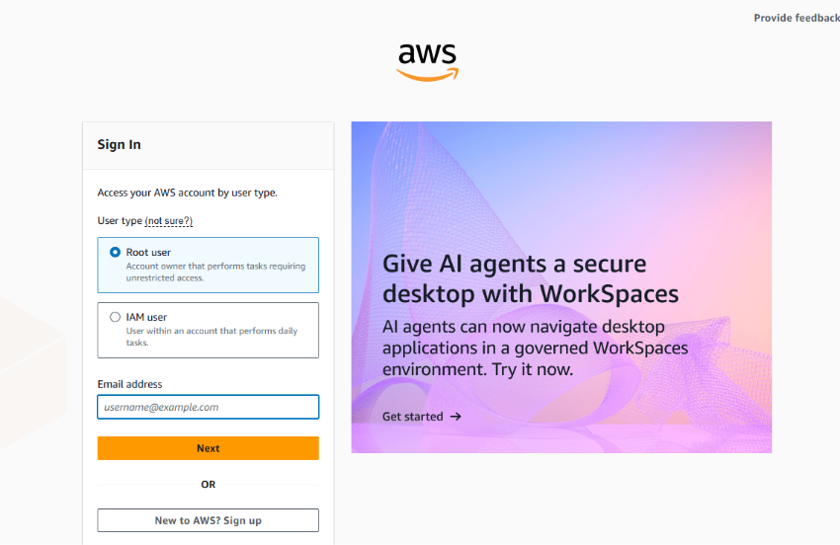

2.1 Ingreso con usuario Root
1. Seleccionar Root user → ingresar email → Next
2. Ingresar contraseña
3. Ingresar código MFA
4. Se muestra el dashboard de la consola
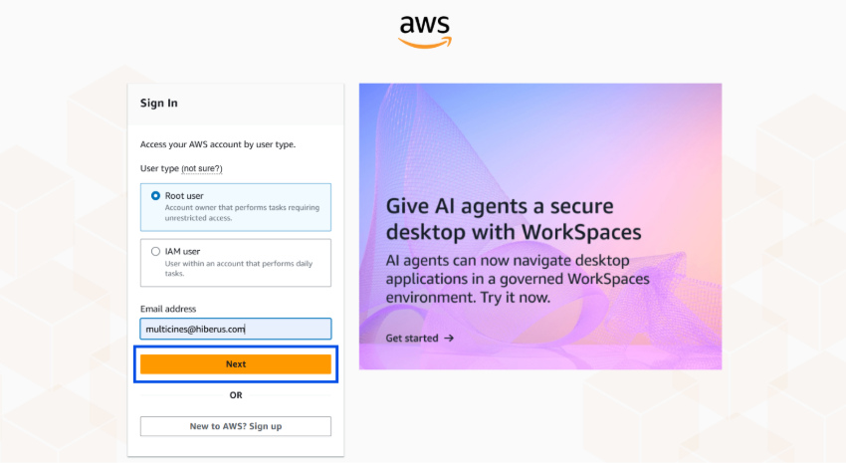
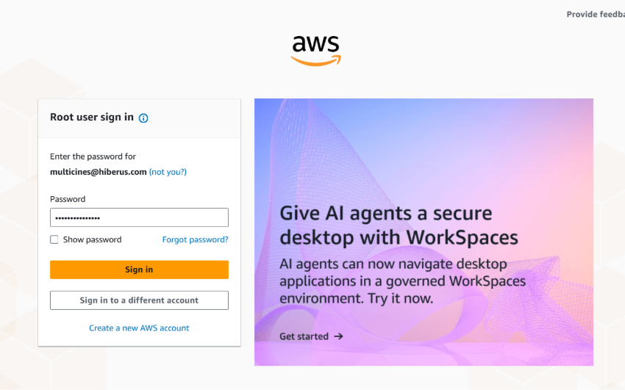
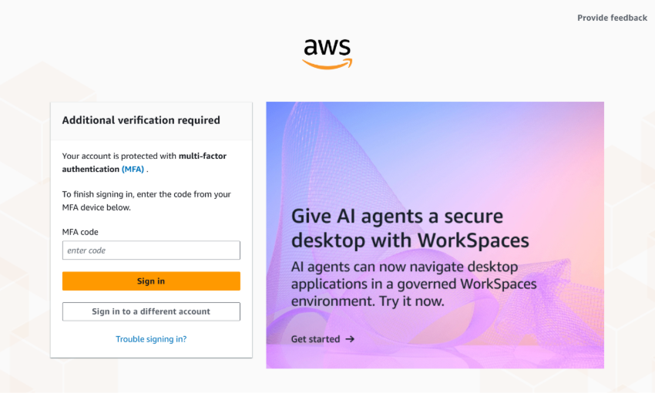
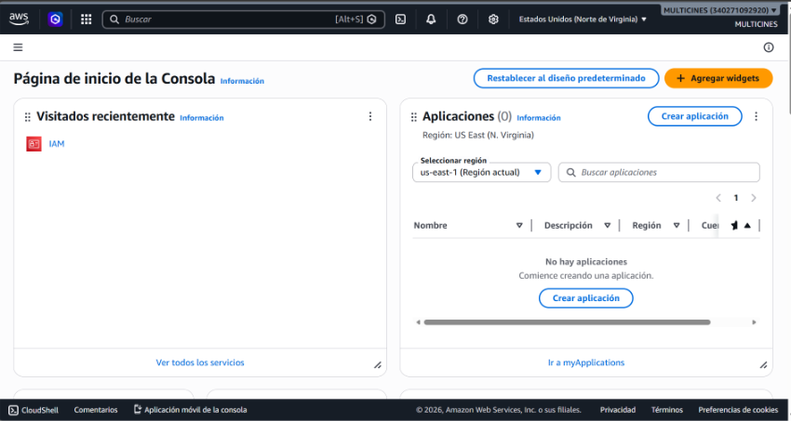

2.2 Ingreso con usuario IAM
1. Seleccionar IAM user → Account ID: 340271092920 → Next
2. Ingresar usuario y contraseña → Sign in
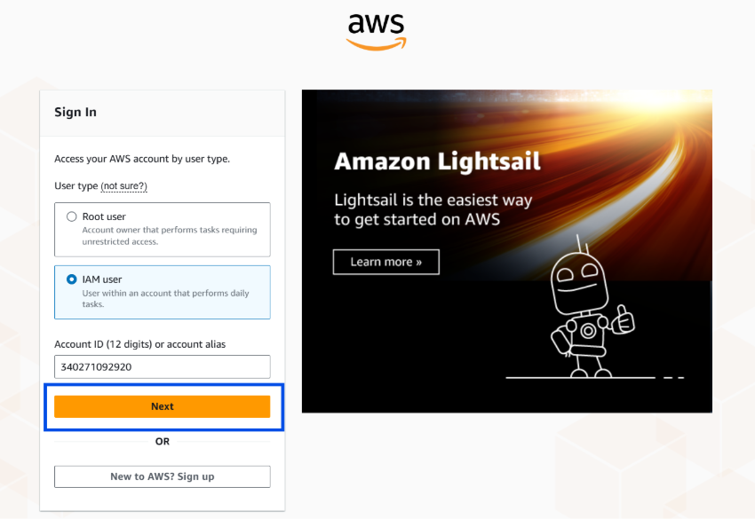
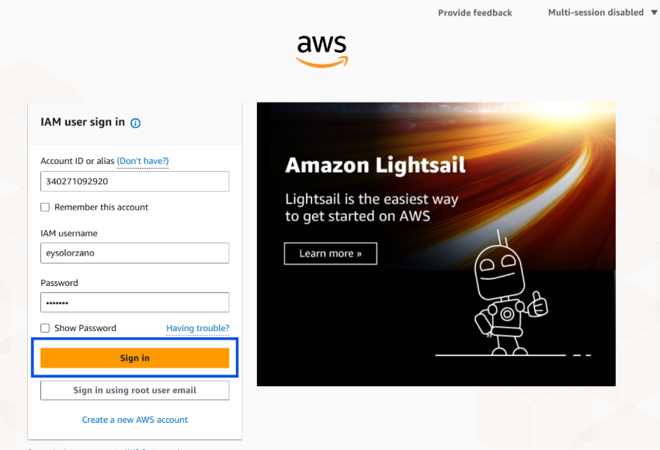
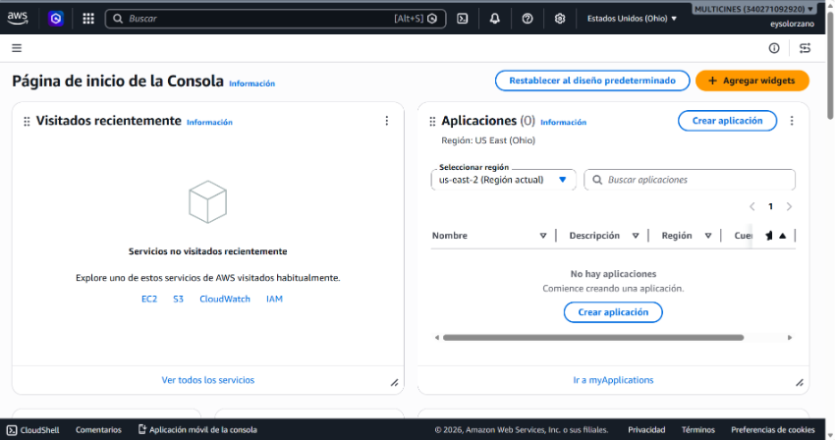

3. Administración de Acceso (IAM)

3.1 Panel de IAM
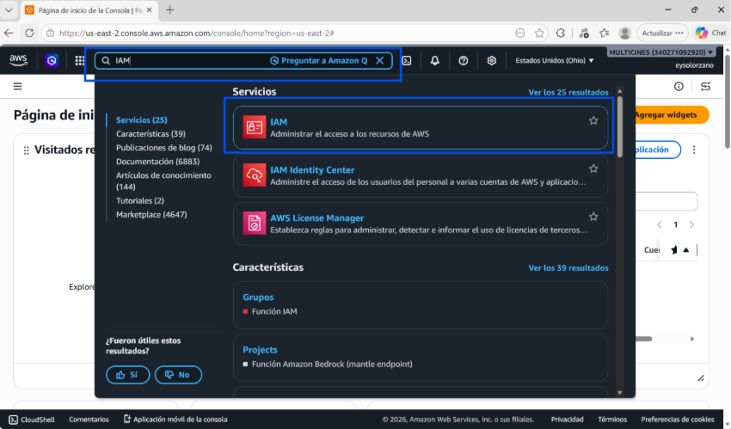
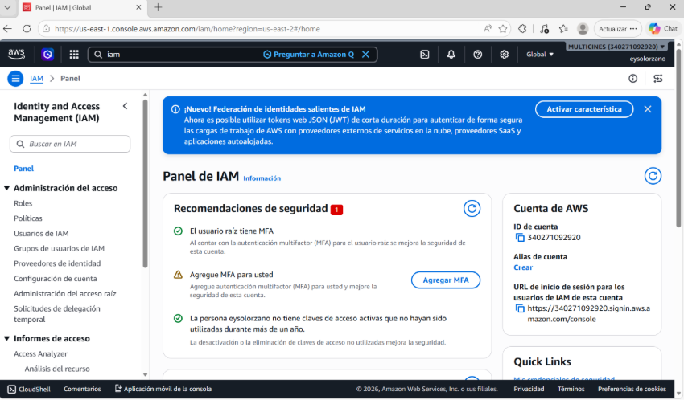

3.2 Grupos IAM
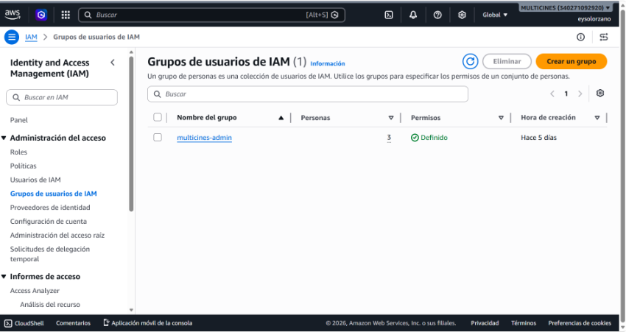
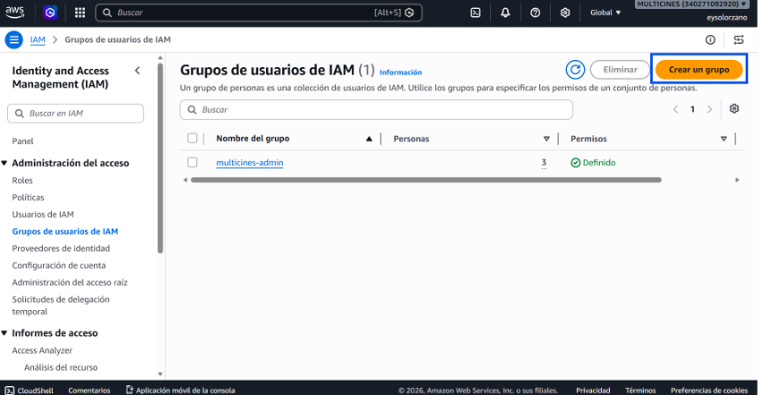
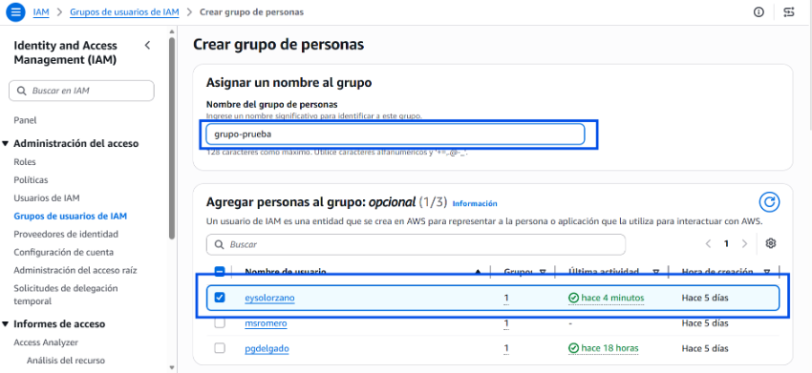
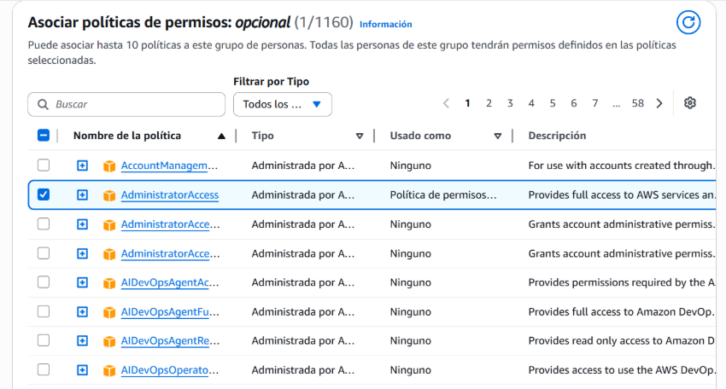
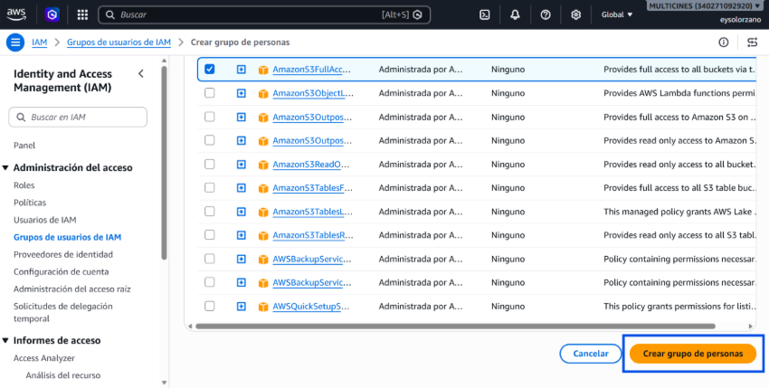
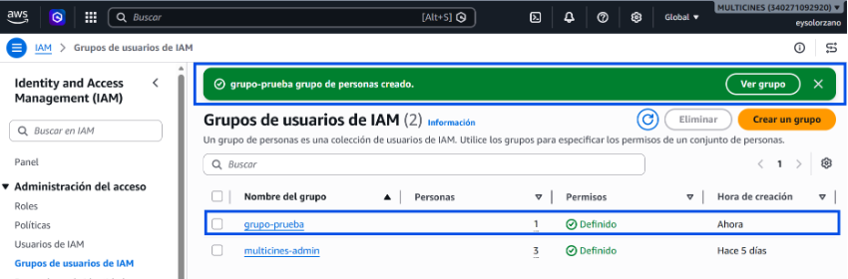
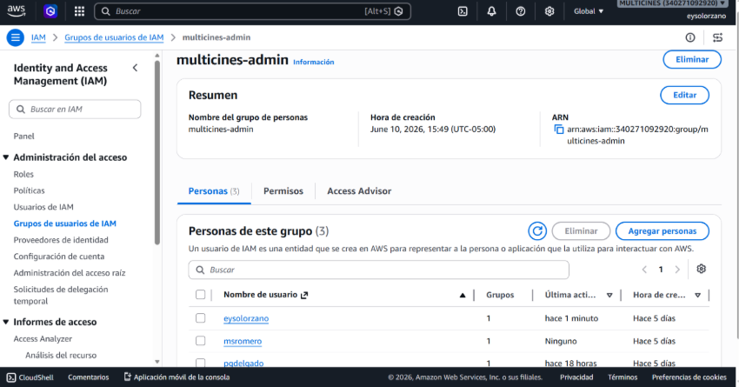
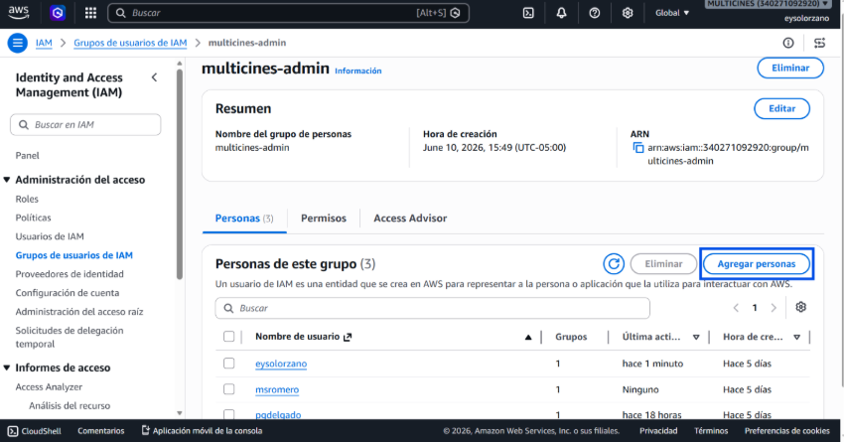

3.3 Usuarios IAM
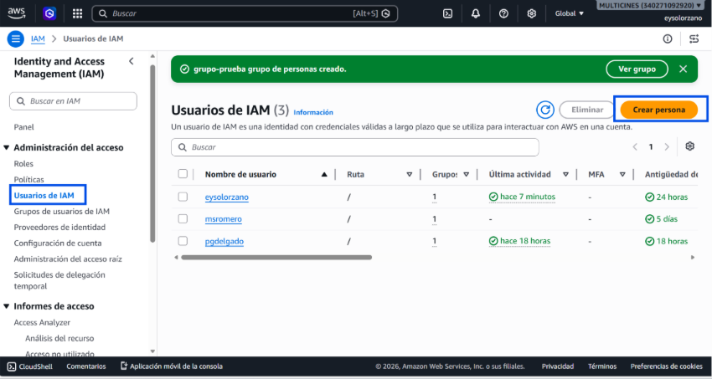
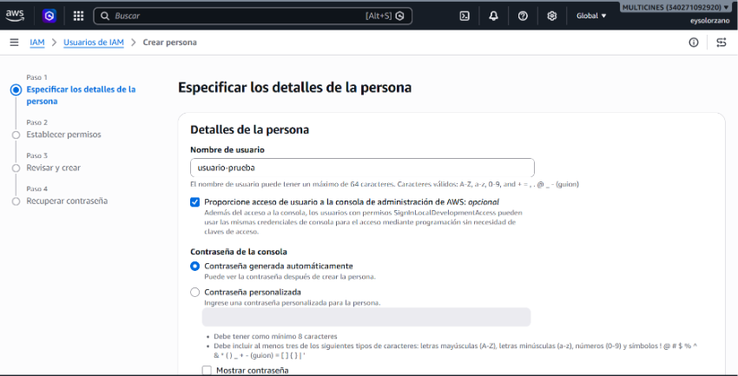
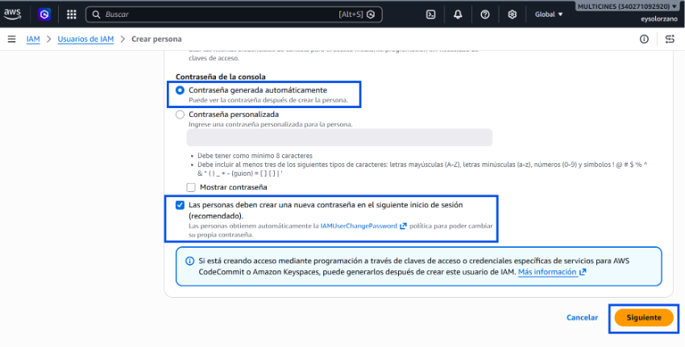
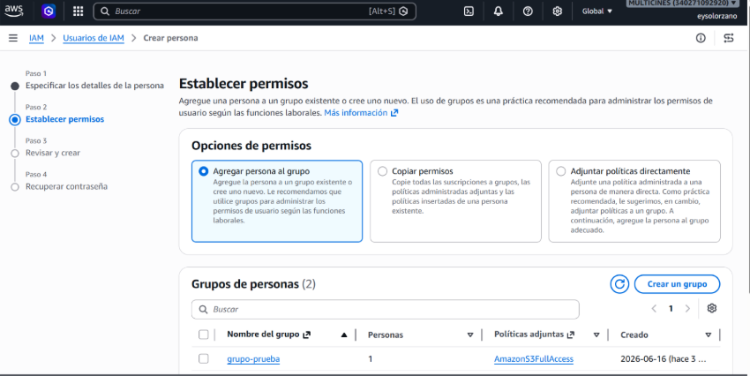
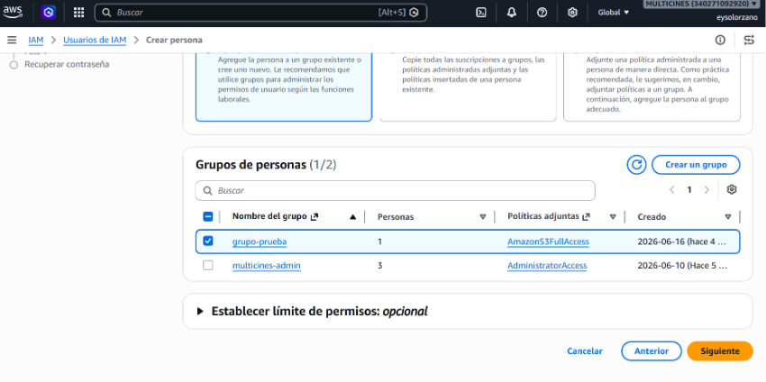
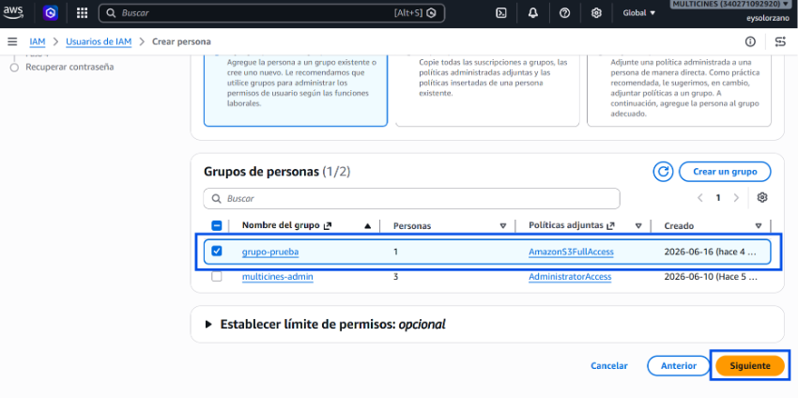
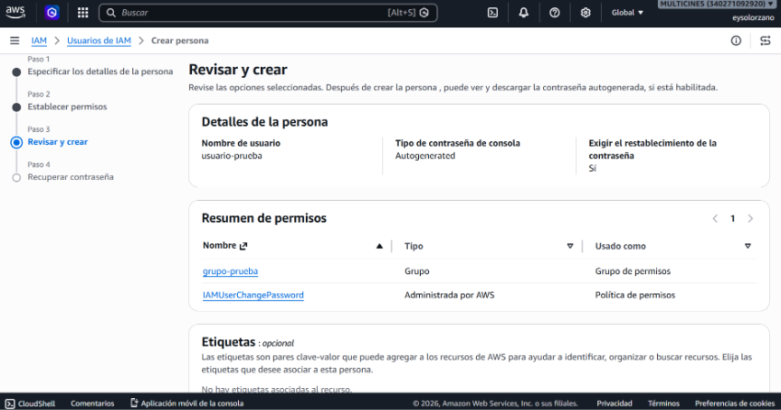
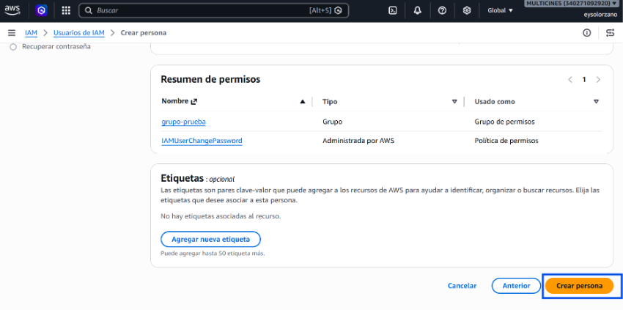
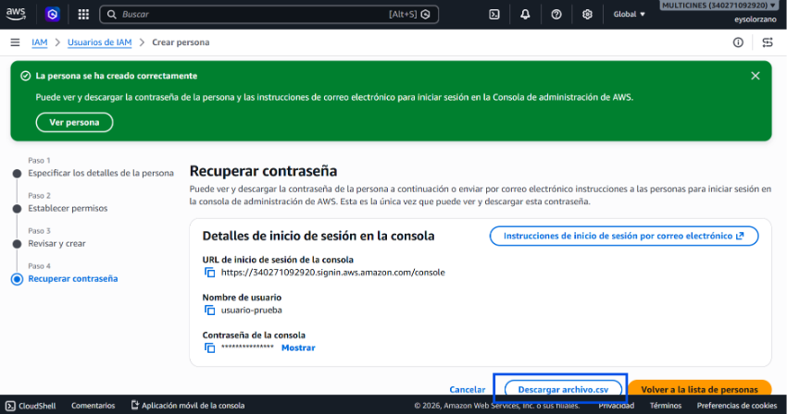
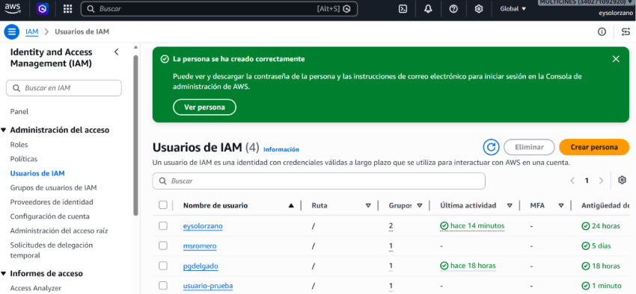

3.4 Políticas IAM
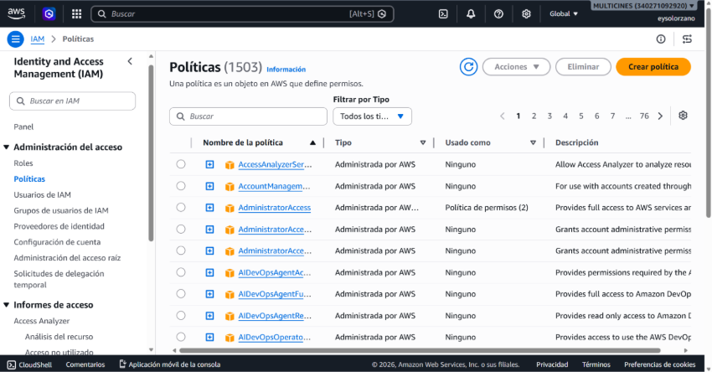
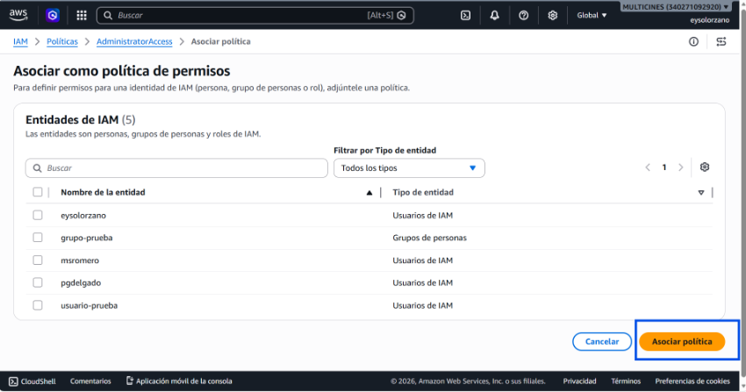

⌨ AWS CLI
# === GRUPOS ===
# Crear grupo
aws iam create-group --group-name Administrators

# Asignar política al grupo
aws iam attach-group-policy --group-name Administrators \
--policy-arn arn:aws:iam::aws:policy/AdministratorAccess

# Crear grupo read-only
aws iam create-group --group-name ReadOnlyUsers
aws iam attach-group-policy --group-name ReadOnlyUsers \
--policy-arn arn:aws:iam::aws:policy/ReadOnlyAccess

# Listar grupos
aws iam list-groups

# === USUARIOS ===
# Crear usuario con acceso a consola
aws iam create-user --user-name gustavo.paredes@hiberus.com
aws iam create-login-profile --user-name gustavo.paredes@hiberus.com \
--password <TEMP_PASSWORD> --password-reset-required

# Agregar usuario a grupo
aws iam add-user-to-group --user-name gustavo.paredes@hiberus.com --group-name Administrators

# Listar usuarios
aws iam list-users

# === POLÍTICAS ===
# Listar políticas adjuntas a un grupo
aws iam list-attached-group-policies --group-name Administrators

# Listar políticas adjuntas a un usuario
aws iam list-attached-user-policies --user-name gustavo.paredes@hiberus.com

# Asignar política directamente a usuario (no recomendado, usar grupos)
aws iam attach-user-policy --user-name <USER> --policy-arn <POLICY_ARN>

3.5 Roles del Proyecto
Rol | ARN | Propósito
ecsTaskExecutionRole | arn:aws:iam::340271092920:role/ecsTaskExecutionRole | Ejecución ECS
multicines-ecs-task-role | arn:aws:iam::340271092920:role/multicines-ecs-task-role | Task role + X-Ray
multicines-github-actions-role | arn:aws:iam::340271092920:role/multicines-github-actions-role | CI/CD OIDC

⌨ AWS CLI
# Crear rol de ejecución ECS
aws iam create-role --role-name ecsTaskExecutionRole \
--assume-role-policy-document file://ecs-trust-policy.json

aws iam attach-role-policy --role-name ecsTaskExecutionRole \
--policy-arn arn:aws:iam::aws:policy/service-role/AmazonECSTaskExecutionRolePolicy

# Crear task role con X-Ray
aws iam create-role --role-name multicines-ecs-task-role \
--assume-role-policy-document file://ecs-trust-policy.json

aws iam put-role-policy --role-name multicines-ecs-task-role \
--policy-name dev-multicines-integration-xray-policy \
--policy-document file://xray-policy.json

4. Administración de VPC

4.1 VPCs del proyecto
VPC | ID | Ambiente
vpc-multicines-dev | vpc-0a5ebea8e7bee9ed5 | dev
prod-vpc-multicines | vpc-0860a0d2cf4df6140 | prod

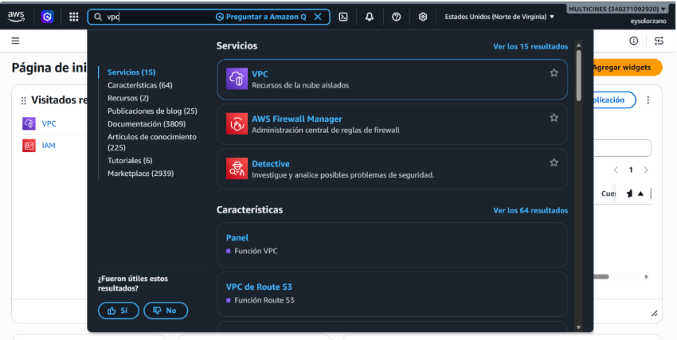
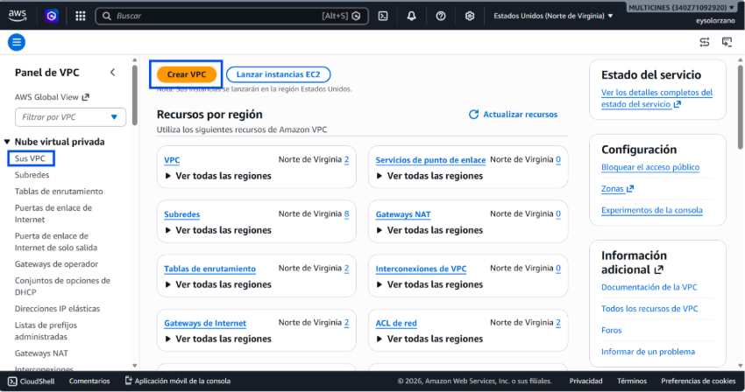
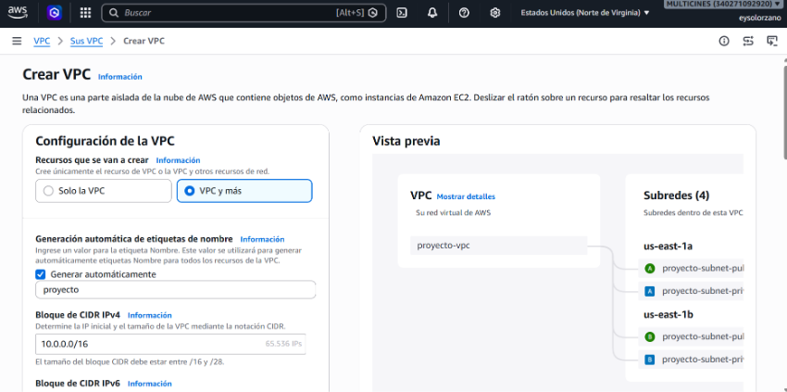
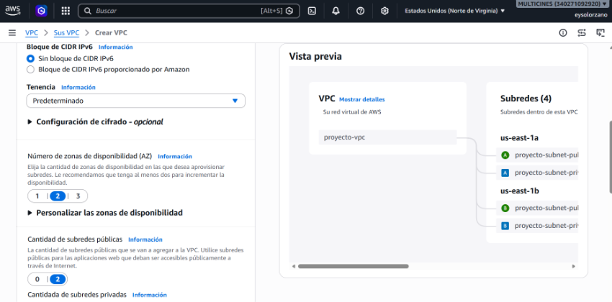
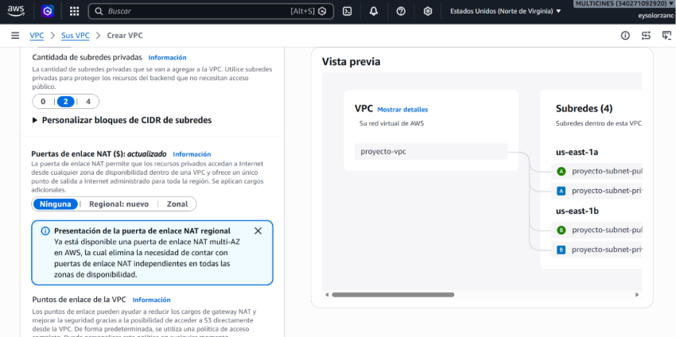
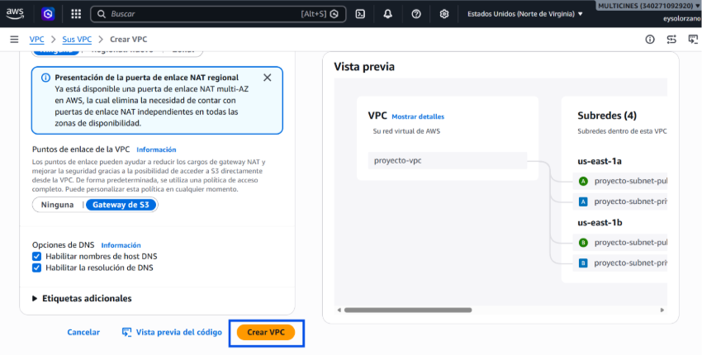
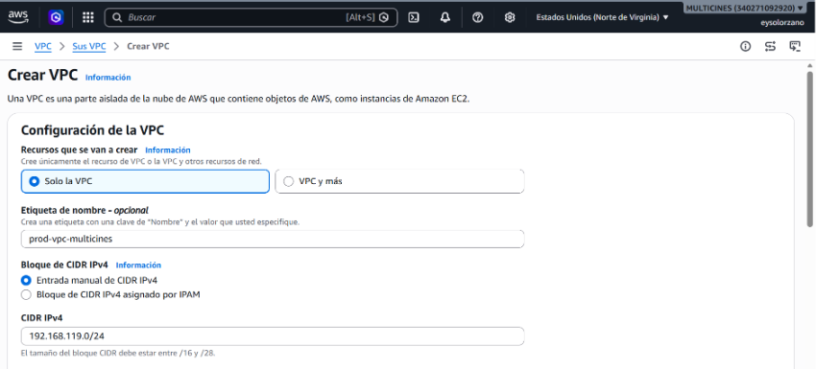
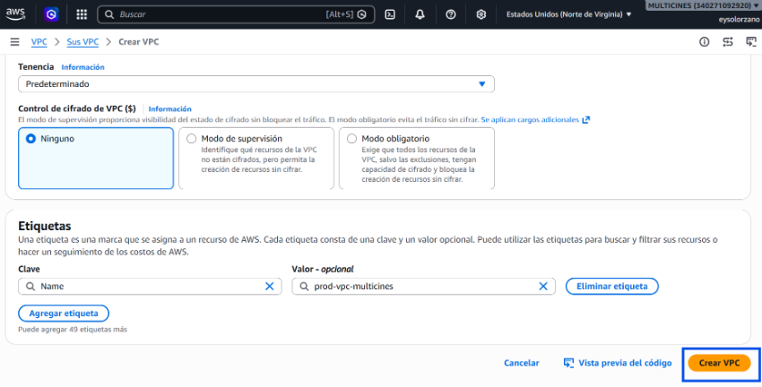
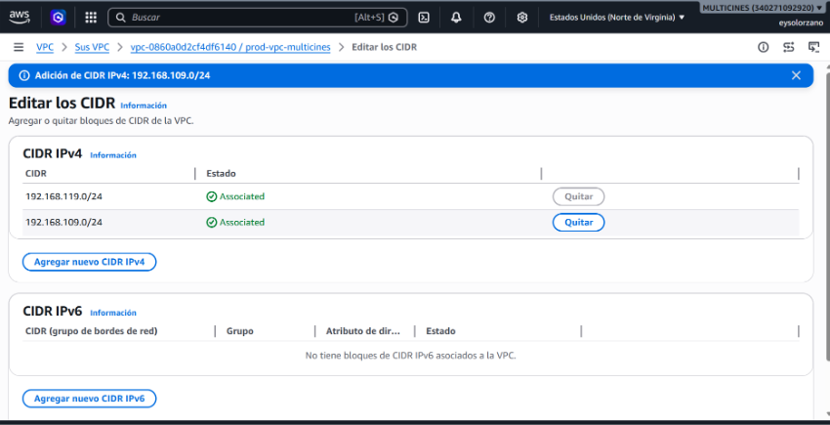
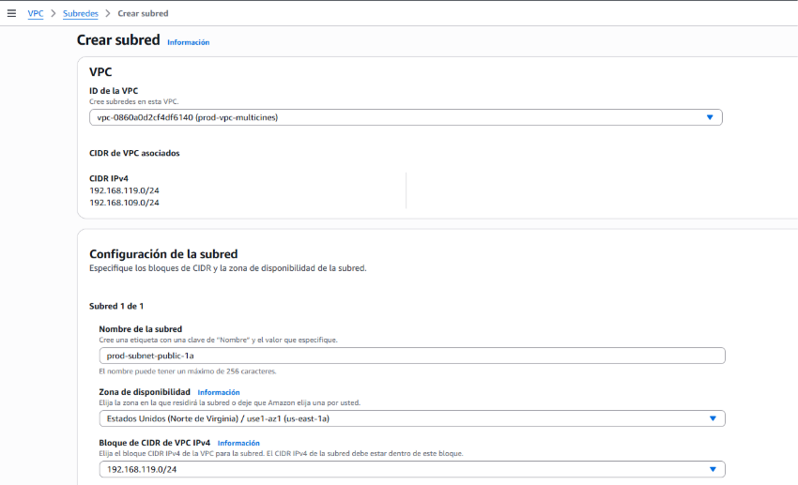
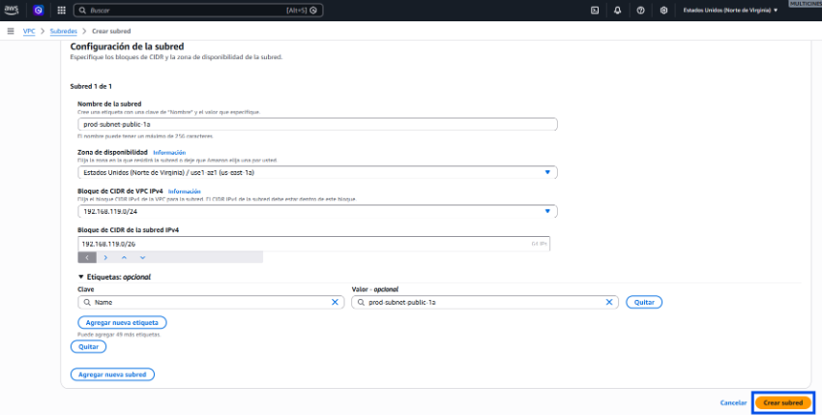

4.2 Internet Gateway
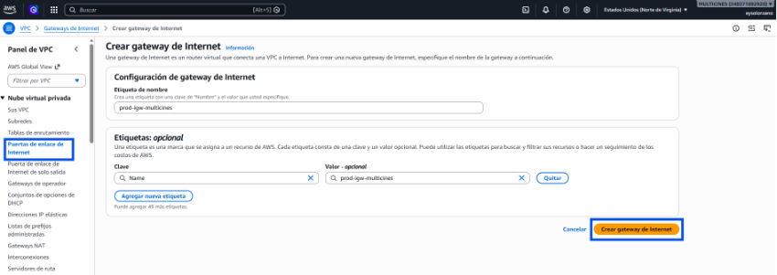
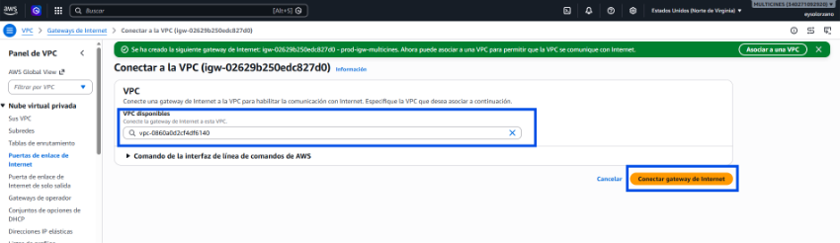

4.3 NAT Gateway
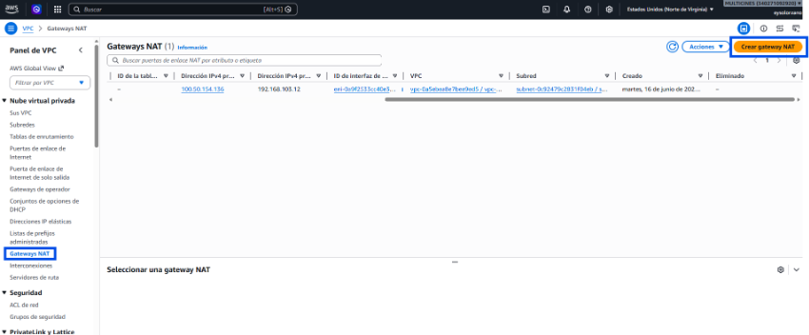
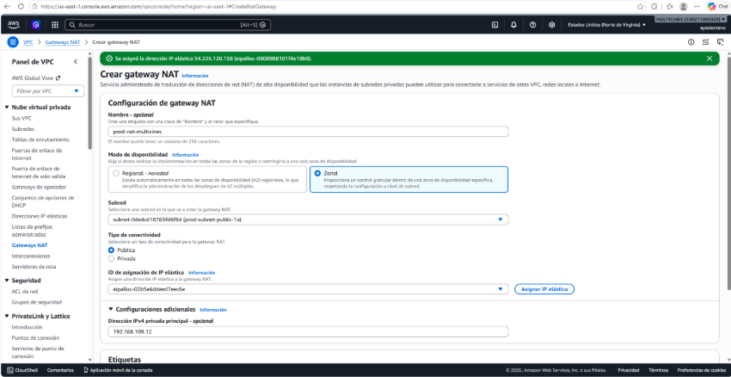
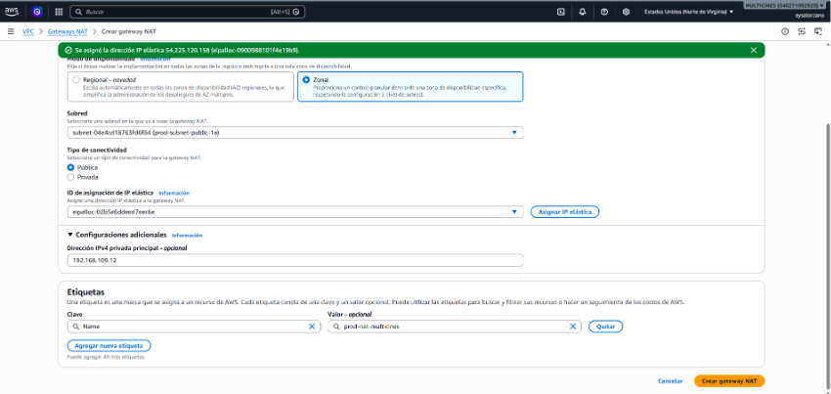

4.4 Security Groups
Security Group | ID | Ambiente
SG ALB | sg-0fdf0c744482646ae | dev
SG ECS | sg-01c619444bab0b8d3 | dev
SG ALB | sg-04f21c4c1d065fe60 | prod
SG ECS | sg-0b78c14cd02b2f6e1 | prod

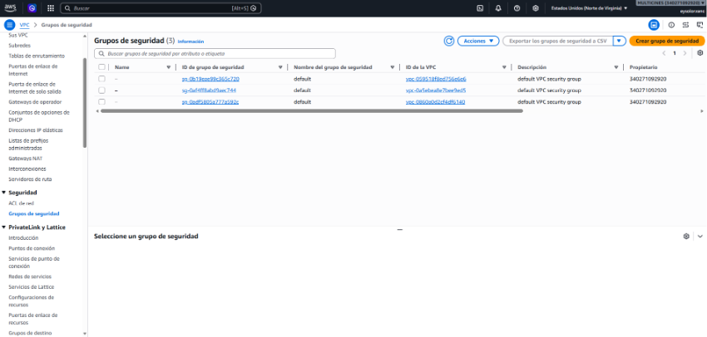
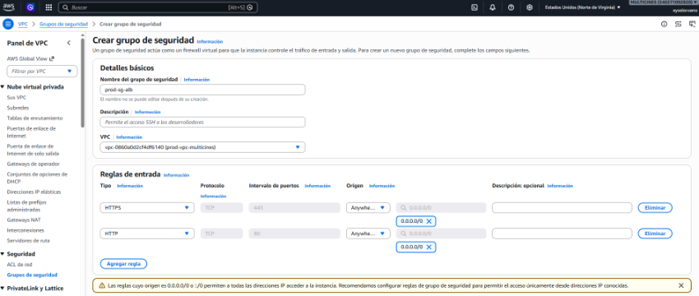
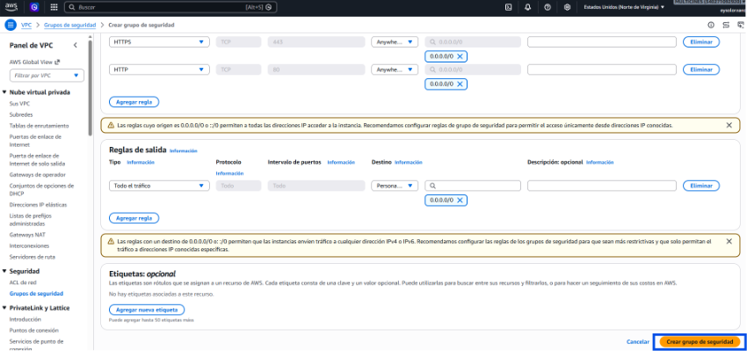
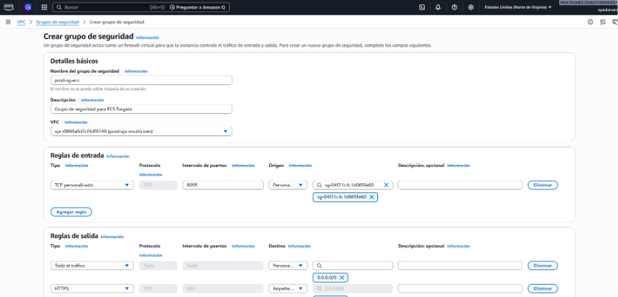
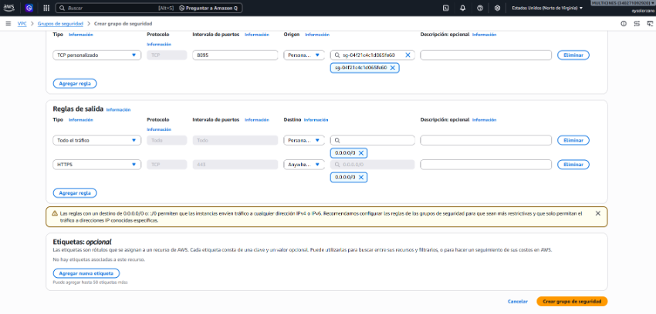

4.5 Tablas de Enrutamiento
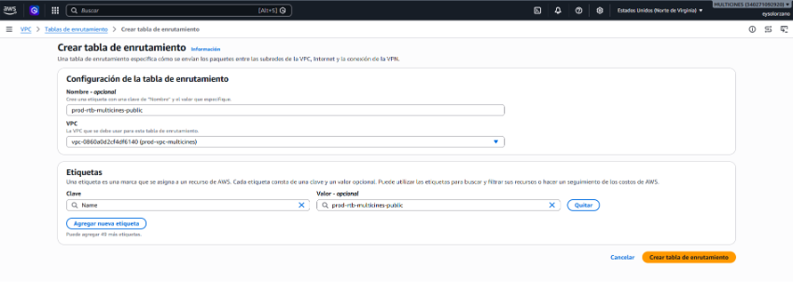
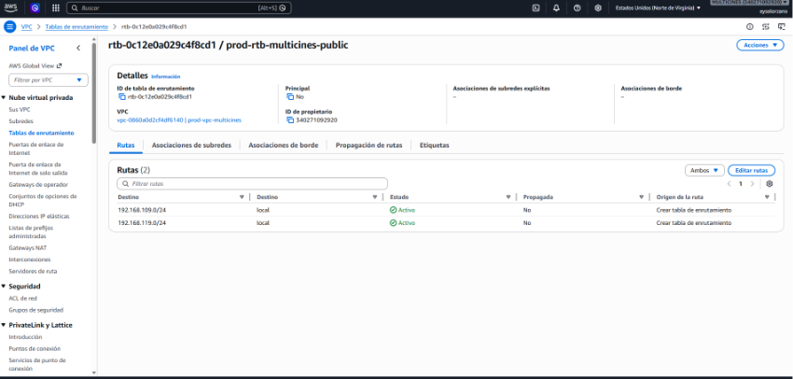
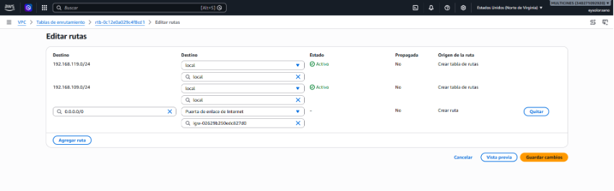
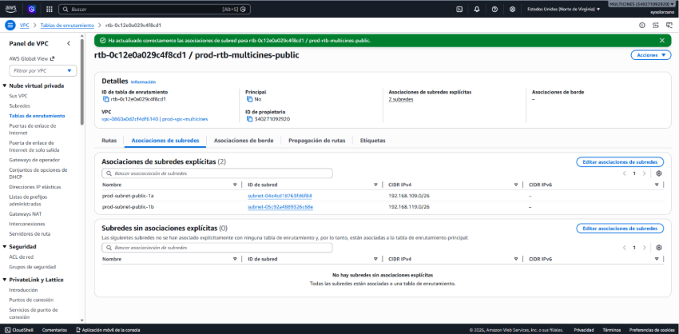
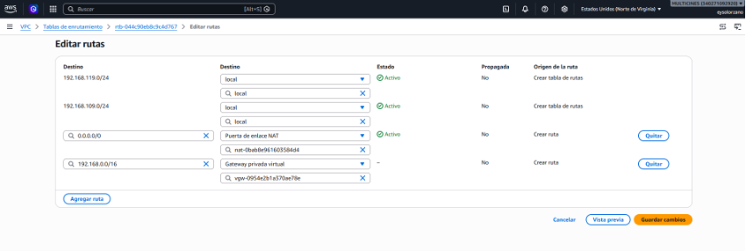

⌨ AWS CLI
# === CONSULTA ===
# Listar VPCs
aws ec2 describe-vpcs --region us-east-1 --query "Vpcs[].{ID:VpcId,CIDR:CidrBlock,Name:Tags[?Key=='Name'].Value|[0]}" --output table

# Listar subnets de una VPC
aws ec2 describe-subnets --filters "Name=vpc-id,Values=vpc-0a5ebea8e7bee9ed5" --region us-east-1 --query "Subnets[].{ID:SubnetId,CIDR:CidrBlock,AZ:AvailabilityZone,Name:Tags[?Key=='Name'].Value|[0]}" --output table

# Listar Security Groups
aws ec2 describe-security-groups --filters "Name=vpc-id,Values=vpc-0a5ebea8e7bee9ed5" --region us-east-1 --query "SecurityGroups[].{ID:GroupId,Name:GroupName}" --output table

# Ver reglas de un SG
aws ec2 describe-security-groups --group-ids sg-0fdf0c744482646ae --region us-east-1

# Listar route tables
aws ec2 describe-route-tables --filters "Name=vpc-id,Values=vpc-0a5ebea8e7bee9ed5" --region us-east-1 --query "RouteTables[].{ID:RouteTableId,Name:Tags[?Key=='Name'].Value|[0]}" --output table

# === CREACIÓN ===
# Crear VPC
aws ec2 create-vpc --cidr-block 10.0.0.0/16 --tag-specifications 'ResourceType=vpc,Tags=[{Key=Name,Value=vpc-multicines-dev}]' --region us-east-1

# Crear subnet
aws ec2 create-subnet --vpc-id <VPC_ID> --cidr-block 10.0.1.0/24 --availability-zone us-east-1a --tag-specifications 'ResourceType=subnet,Tags=[{Key=Name,Value=subnet-dev-public-1a}]' --region us-east-1

# Crear Internet Gateway + attach
aws ec2 create-internet-gateway --tag-specifications 'ResourceType=internet-gateway,Tags=[{Key=Name,Value=dev-igw}]' --region us-east-1
aws ec2 attach-internet-gateway --internet-gateway-id <IGW_ID> --vpc-id <VPC_ID> --region us-east-1

# Crear NAT Gateway
aws ec2 allocate-address --domain vpc --region us-east-1
aws ec2 create-nat-gateway --subnet-id <PUBLIC_SUBNET_ID> --allocation-id <EIP_ID> --tag-specifications 'ResourceType=natgateway,Tags=[{Key=Name,Value=nat-dev}]' --region us-east-1

# Crear Security Group
aws ec2 create-security-group --group-name sg-alb-dev --description "ALB Security Group" --vpc-id <VPC_ID> --region us-east-1
aws ec2 authorize-security-group-ingress --group-id <SG_ID> --protocol tcp --port 443 --cidr 0.0.0.0/0 --region us-east-1

5. Route 53 — DNS
Dominio: cloudmulticines.com | Zone ID: Z02656981PPWUEVYOEMVL

5.1 Registro del dominio
Opción A: Registrar dominio en Route53 (recomendado)
1. Route 53 → Registered domains → Register domains
2. Buscar: cloudmulticines.com → Select → Proceed to checkout
3. Llenar datos de contacto → aceptar términos → Submit
4. Costo: ~$12/año. AWS auto-crea la hosted zone y configura NS.

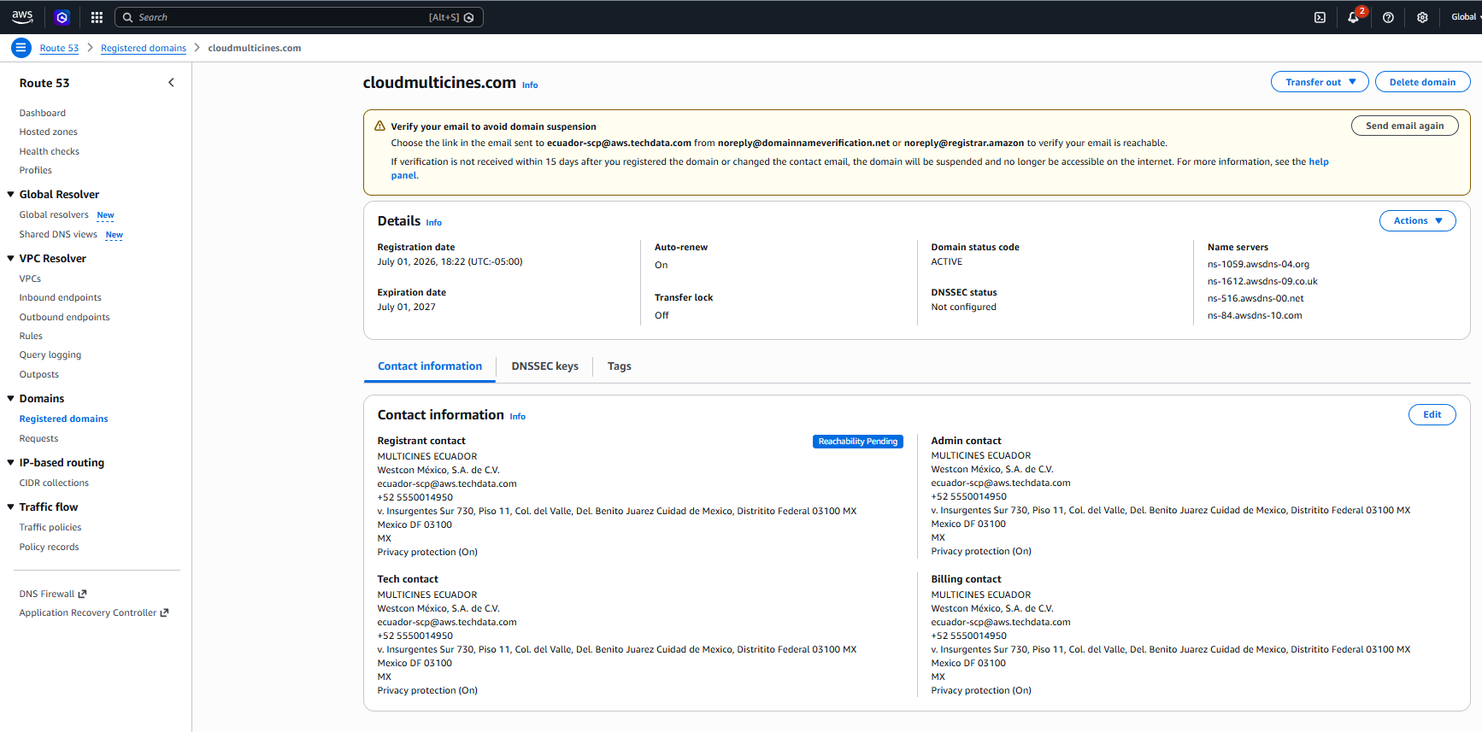
Opción B: Crear hosted zone manualmente (dominio externo)
1. Route 53 → Hosted zones → Create hosted zone
2. Domain name: cloudmulticines.com → Type: Public → Create
3. Copiar los 4 nameservers y configurarlos en el registrador externo

⌨ AWS CLI
# Opción B: Crear hosted zone manual
aws route53 create-hosted-zone --name cloudmulticines.com \
--caller-reference "create-$(date +%s)"

# Ver nameservers de la zona
aws route53 get-hosted-zone --id Z02656981PPWUEVYOEMVL \
--query "DelegationSet.NameServers"

# Listar hosted zones
aws route53 list-hosted-zones

5.2 Registros DNS
Registro | Tipo | Target | Ambiente
api-dev.cloudmulticines.com | A (Alias) | ALB dev | dev
api.cloudmulticines.com | A (Alias) | ALB prod | prod

Crear registro A alias (consola)
1. Route 53 → Hosted zones → cloudmulticines.com → Create record
2. Record name: api-dev (o api para prod)
3. Record type: A → Toggle Alias: ON
4. Route traffic to: Application Load Balancer → us-east-1 → seleccionar ALB
5. Evaluate target health: Yes → Create records

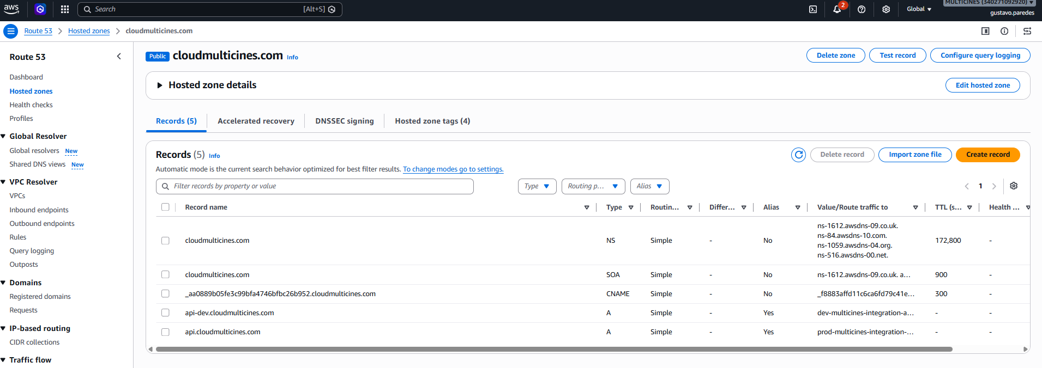

⌨ AWS CLI
# Crear registro A alias (dev)
aws route53 change-resource-record-sets \
--hosted-zone-id Z02656981PPWUEVYOEMVL \
--change-batch file://route53-dev-record.json

# Ejemplo route53-dev-record.json:
# {"Changes":[{"Action":"UPSERT","ResourceRecordSet":{
# "Name":"api-dev.cloudmulticines.com","Type":"A",
# "AliasTarget":{"HostedZoneId":"<ALB_ZONE>",
# "DNSName":"dev-multicines-integration-alb-1885310298.us-east-1.elb.amazonaws.com",
# "EvaluateTargetHealth":true}}}]}

# Listar records
aws route53 list-resource-record-sets --hosted-zone-id Z02656981PPWUEVYOEMVL

# Eliminar record
# Usar Action: "DELETE" en el change-batch con mismos valores

6. Certificados SSL — ACM
Certificado wildcard *.cloudmulticines.com solicitado via DNS validation en ACM. Se auto-renueva mientras el CNAME de validación exista en la hosted zone.

6.1 Solicitar certificado (DNS validation)
Parámetro | Valor
Dominio | *.cloudmulticines.com
Método | DNS validation (auto-renovable)
Estado | ISSUED
ARN | arn:aws:acm:us-east-1:340271092920:certificate/eb5ce963-b419-4672-bb8a-7ed97becfafc
Tags | Name=multicines-integration-acm, Environment=shared

Paso a paso (consola)
1. Certificate Manager → Request certificate → Request a public certificate → Next
2. Domain names: *.cloudmulticines.com
3. Validation method: DNS validation
4. Key algorithm: RSA 2048
5. Tags: Name=multicines-integration-acm, Project=multicines, Environment=shared
6. Click Request
7. En el certificado → Create records in Route 53 (crea CNAME automáticamente)
8. Esperar 2-5 minutos → estado cambia a ISSUED

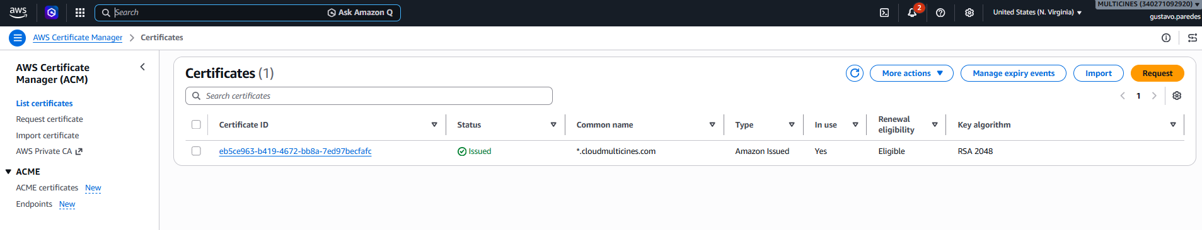
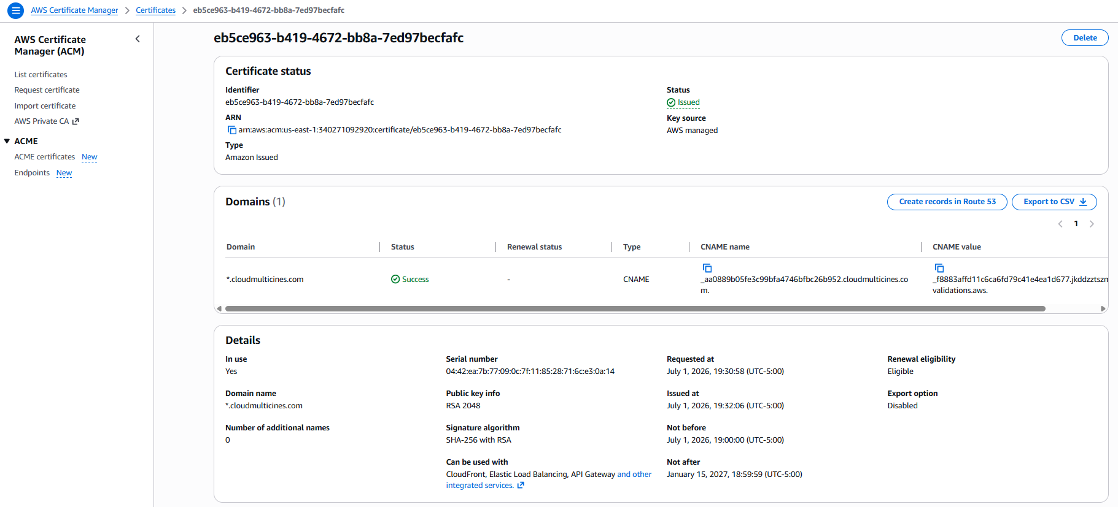

6.2 Renovación
El certificado se auto-renueva ~60 días antes de expirar. Requisitos: que el CNAME de validación exista y que el cert esté asociado a un recurso (ALB). No requiere acción manual.

⌨ AWS CLI
# Solicitar certificado wildcard
aws acm request-certificate \
--domain-name "*.cloudmulticines.com" \
--validation-method DNS \
--tags Key=Name,Value=multicines-integration-acm Key=Project,Value=multicines Key=Environment,Value=shared \
--region us-east-1

# Ver estado del certificado
aws acm describe-certificate \
--certificate-arn arn:aws:acm:us-east-1:340271092920:certificate/eb5ce963-b419-4672-bb8a-7ed97becfafc \
--region us-east-1 --query "Certificate.{Status:Status,Expiry:NotAfter}"

# Listar certificados
aws acm list-certificates --region us-east-1

# Eliminar certificado (solo si no está asociado a ALB)
aws acm delete-certificate --certificate-arn <ARN> --region us-east-1

7. Application Load Balancer
El ALB distribuye tráfico HTTPS al Target Group con las tareas ECS. Incluye listener HTTPS:443 con TLS 1.3 y redirect HTTP:80→HTTPS.

7.1 ALBs existentes
ALB | DNS | Ambiente
dev-multicines-integration-alb | dev-multicines-integration-alb-1885310298.us-east-1.elb.amazonaws.com | dev
prod-multicines-integration-alb | prod-multicines-integration-alb-43560610.us-east-1.elb.amazonaws.com | prod

7.2 Configuración
Parámetro | Dev | Prod
Tipo | application, internet-facing | application, internet-facing
SSL Policy | ELBSecurityPolicy-TLS13-1-2-2021-06 | ELBSecurityPolicy-TLS13-1-2-2021-06
Certificado | *.cloudmulticines.com | *.cloudmulticines.com
Listener HTTPS | 443 → Forward to TG | 443 → Forward to TG
Listener HTTP | 80 → Redirect HTTPS 301 | 80 → Redirect HTTPS 301
Target Group | dev-multicines-integration-tg | prod-multicines-integration-tg
TG Port | 8095 | 8095
Health Check | /actuator/health:8095 | /actuator/health:8095
Healthy/Unhealthy | 2 / 5 | 2 / 5

Crear ALB (consola)
1. EC2 → Load Balancers → Create Load Balancer → Application Load Balancer
2. Name: {env}-multicines-integration-alb, Scheme: Internet-facing
3. Network mapping: VPC + 2 subnets públicas del ambiente
4. Security groups: SG ALB del ambiente
5. Listener HTTPS:443 → cert ACM *.cloudmulticines.com → Policy TLS 1.3
6. Target Group: Create → IP type, port 8095, health check /actuator/health
7. Agregar listener HTTP:80 → Redirect HTTPS 301

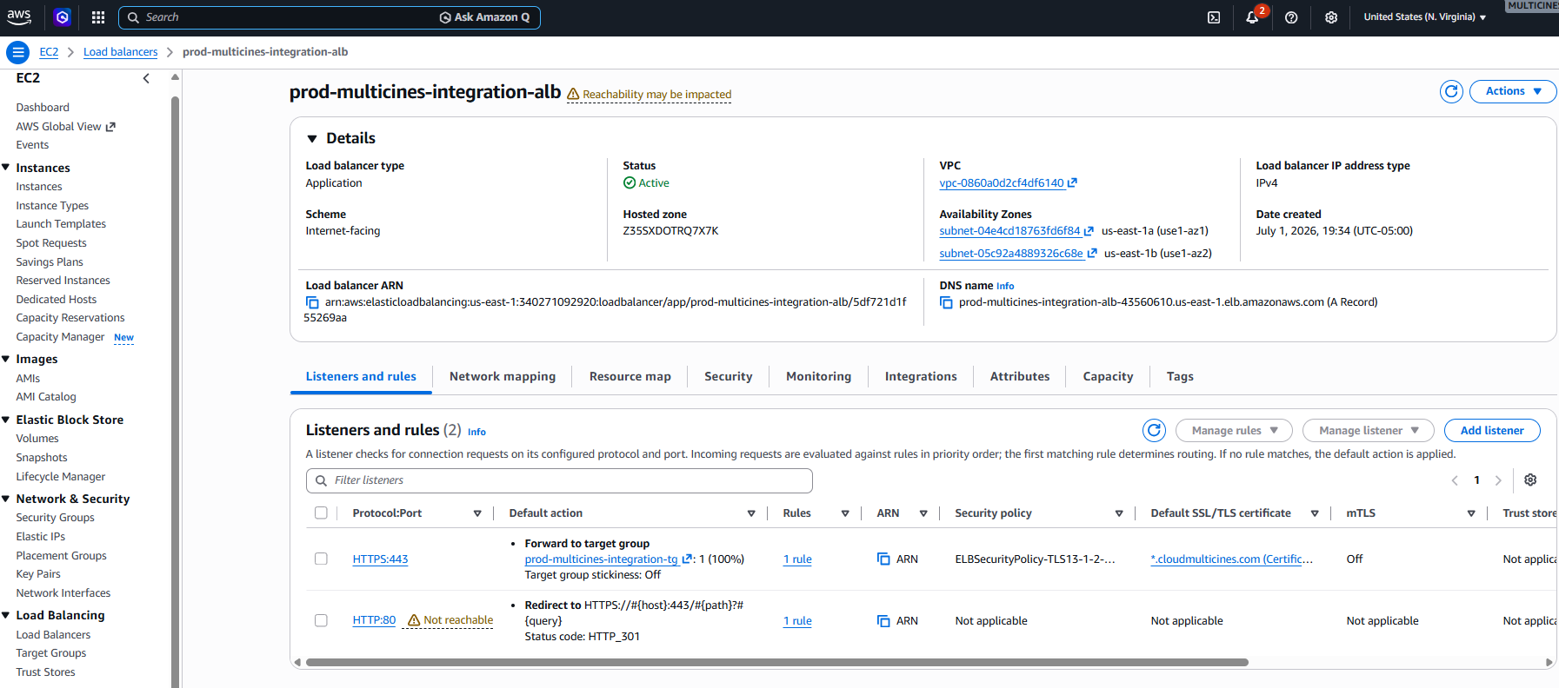
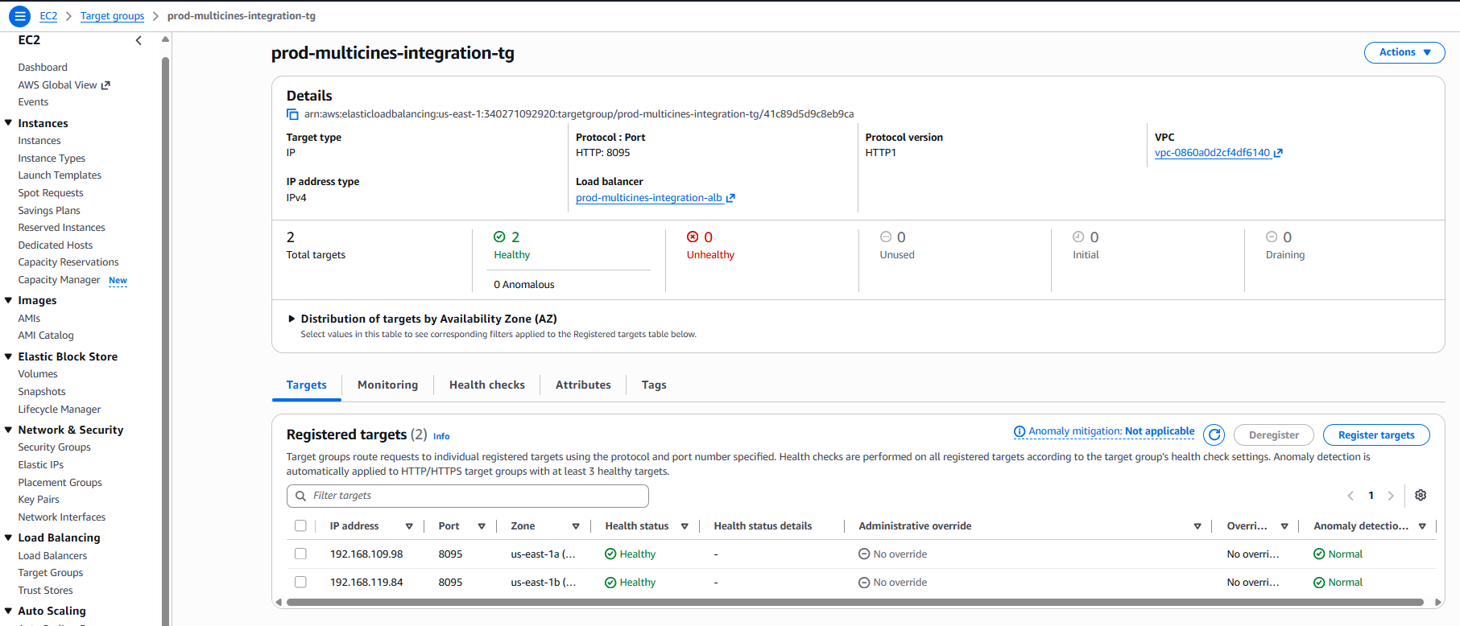

⌨ AWS CLI
# Crear ALB (ejemplo dev)
aws elbv2 create-load-balancer --name dev-multicines-integration-alb \
--type application --scheme internet-facing \
--subnets subnet-0c92479c2831f04eb subnet-02193c97ceb6ec25d \
--security-groups sg-0fdf0c744482646ae \
--tags Key=Name,Value=dev-multicines-integration-alb Key=Project,Value=multicines Key=Environment,Value=dev \
--region us-east-1

# Crear Target Group
aws elbv2 create-target-group --name dev-multicines-integration-tg \
--protocol HTTP --port 8095 --vpc-id vpc-0a5ebea8e7bee9ed5 --target-type ip \
--health-check-path /actuator/health --health-check-port 8095 \
--health-check-interval-seconds 30 --health-check-timeout-seconds 10 \
--healthy-threshold-count 2 --unhealthy-threshold-count 5 --region us-east-1

# Crear Listener HTTPS:443
aws elbv2 create-listener --load-balancer-arn <ALB_ARN> \
--protocol HTTPS --port 443 --ssl-policy ELBSecurityPolicy-TLS13-1-2-2021-06 \
--certificates CertificateArn=arn:aws:acm:us-east-1:340271092920:certificate/eb5ce963-b419-4672-bb8a-7ed97becfafc \
--default-actions Type=forward,TargetGroupArn=<TG_ARN> --region us-east-1

# Crear Listener HTTP:80 redirect
aws elbv2 create-listener --load-balancer-arn <ALB_ARN> \
--protocol HTTP --port 80 \
--default-actions 'Type=redirect,RedirectConfig={Protocol=HTTPS,Port=443,StatusCode=HTTP_301}' --region us-east-1

# Eliminar: listeners → ALB → Target Group
aws elbv2 delete-listener --listener-arn <ARN> --region us-east-1
aws elbv2 delete-load-balancer --load-balancer-arn <ARN> --region us-east-1
aws elbv2 delete-target-group --target-group-arn <ARN> --region us-east-1

8. Secrets Manager
Almacena credenciales sensibles cifradas por ambiente. Los secretos son consumidos por las tareas ECS en tiempo de ejecución.

8.1 Secretos existentes
Nombre | Ambiente
platform/dev/resilience | dev
integrator/dev/app | dev
platform/prod/resilience | prod
integrator/prod/app | prod

Crear secreto (consola)
1. Secrets Manager → Store a new secret
2. Secret type: Other type of secret
3. Key/value: Plaintext → pegar JSON compactado
4. Encryption key: aws/secretsmanager (default) → Next
5. Secret name: ej. platform/dev/resilience
6. Tags: Name, Project=multicines, Environment={env} → Next → Store

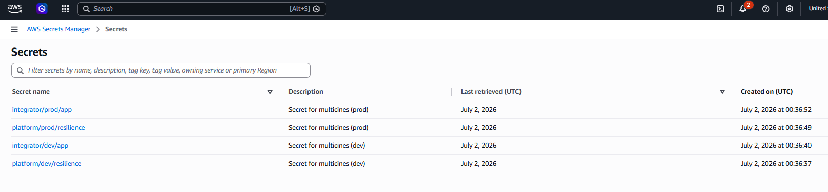

⌨ AWS CLI
# Crear secreto
aws secretsmanager create-secret --name platform/dev/resilience \
--secret-string '{"db_host":"...","db_pass":"..."}' \
--tags Key=Name,Value=platform/dev/resilience Key=Project,Value=multicines Key=Environment,Value=dev \
--region us-east-1

# Obtener valor
aws secretsmanager get-secret-value --secret-id platform/dev/resilience --region us-east-1

# Actualizar valor
aws secretsmanager update-secret --secret-id platform/dev/resilience \
--secret-string '{"db_host":"...","db_pass":"new"}' --region us-east-1

# Eliminar (sin período de recuperación)
aws secretsmanager delete-secret --secret-id platform/dev/resilience \
--force-delete-without-recovery --region us-east-1

# Listar secretos
aws secretsmanager list-secrets --region us-east-1

9. Elastic Container Registry (ECR)
Repositorio privado: multicines/integration-service
URI: 340271092920.dkr.ecr.us-east-1.amazonaws.com/multicines/integration-service
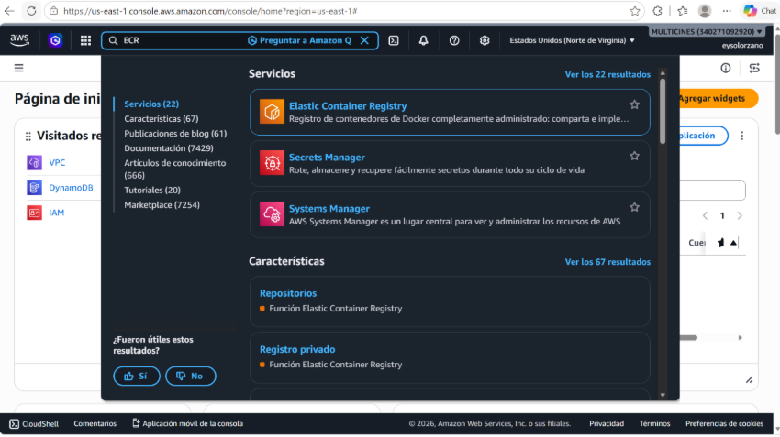
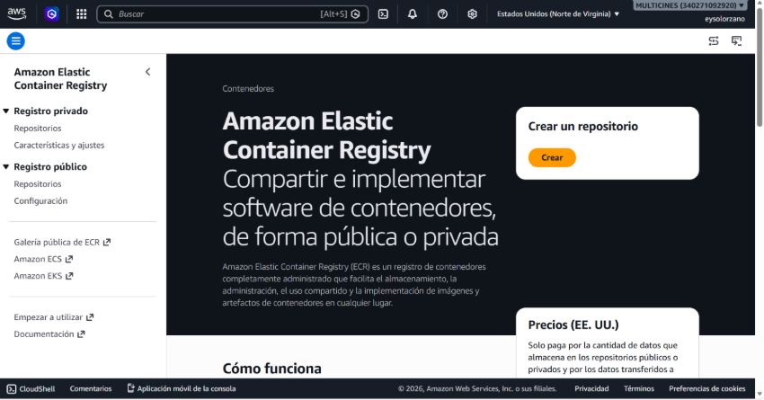
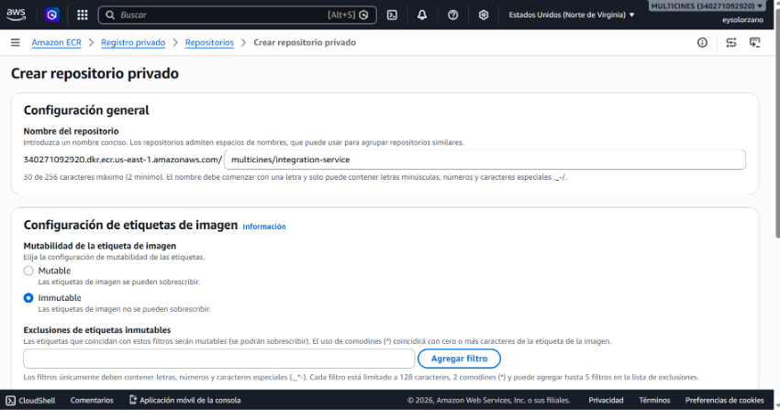
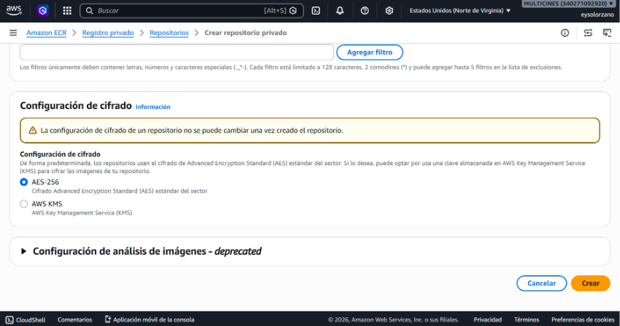
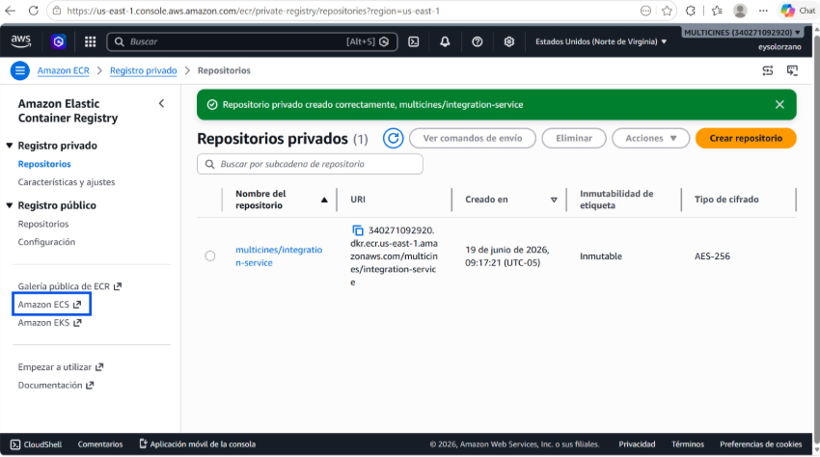

⌨ AWS CLI
# Login a ECR
aws ecr get-login-password --region us-east-1 | \
docker login --username AWS --password-stdin 340271092920.dkr.ecr.us-east-1.amazonaws.com

# Crear repositorio
aws ecr create-repository --repository-name multicines/integration-service \
--image-tag-mutability IMMUTABLE --encryption-configuration encryptionType=AES256 \
--region us-east-1

# Build, tag y push
docker build -t multicines/integration-service:dev-latest .
docker tag multicines/integration-service:dev-latest \
340271092920.dkr.ecr.us-east-1.amazonaws.com/multicines/integration-service:dev-latest
docker push 340271092920.dkr.ecr.us-east-1.amazonaws.com/multicines/integration-service:dev-latest

# Listar imágenes
aws ecr list-images --repository-name multicines/integration-service --region us-east-1

10. Elastic Container Service (ECS)
Cluster: multicines-cluster (Fargate). Servicios con sidecar ADOT para trazas X-Ray.

10.1 Cluster
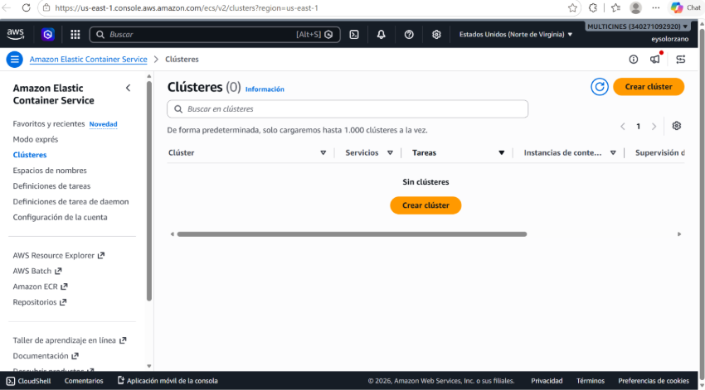
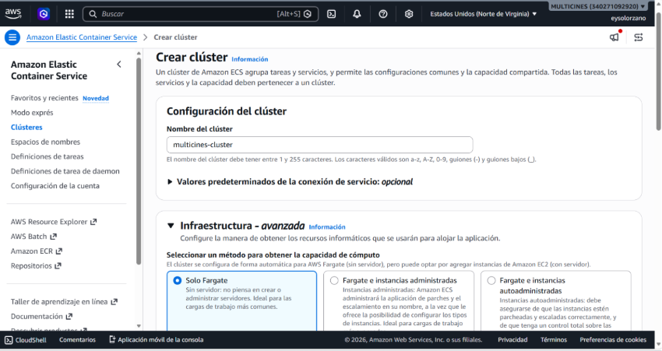
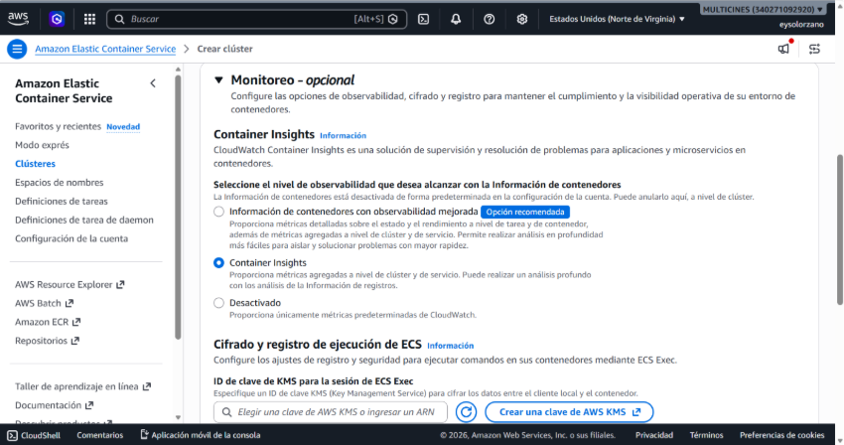
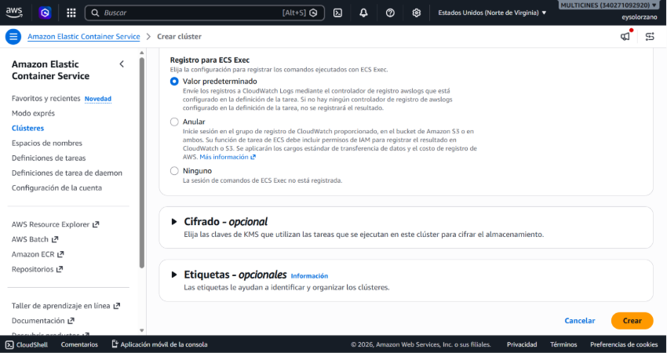
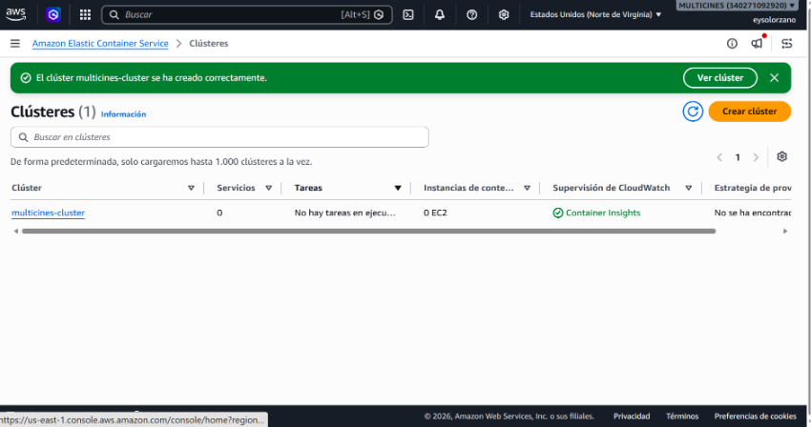

10.2 Servicios
Servicio | Tasks | Estado
dev-multicines-integration-svc | 1/1 | ACTIVE
prod-multicines-integration-svc | 2/2 | ACTIVE

10.3 Task Definition
Parámetro | Dev | Prod
Family | dev-multicines-integration-task | prod-multicines-integration-task
CPU / Memoria | 512 / 1024 MB | 1024 / 2048 MB
Container principal | integration-service:8095 | integration-service:8095
Sidecar ADOT | aws-otel-collector:4317 | aws-otel-collector:4317
Execution Role | ecsTaskExecutionRole | ecsTaskExecutionRole
Task Role | multicines-ecs-task-role | multicines-ecs-task-role
Log group | /ecs/dev-multicines-integration | /ecs/prod-multicines-integration

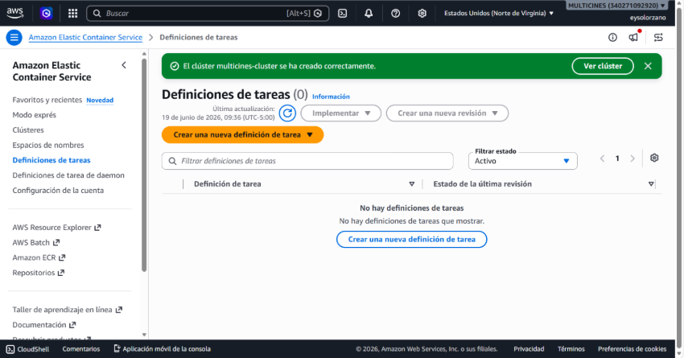
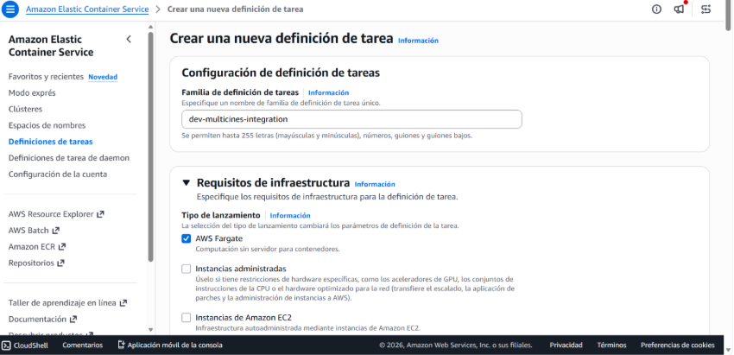
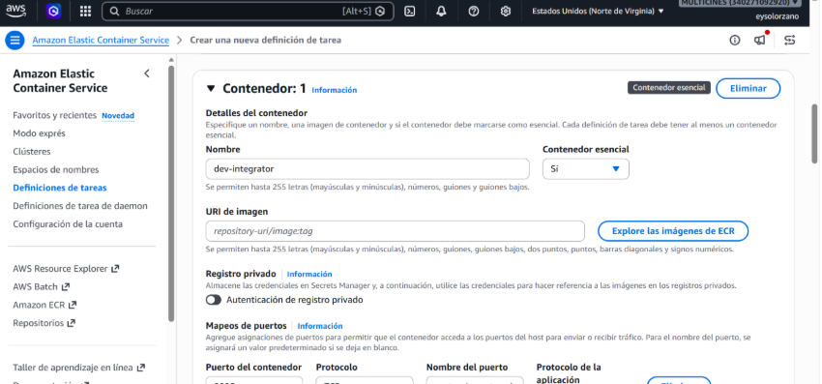
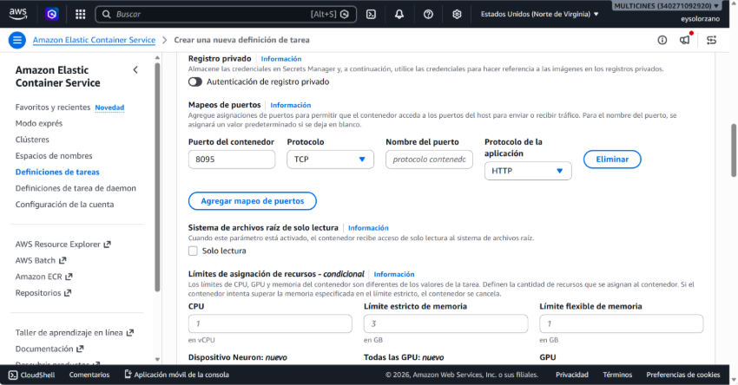

10.4 Variables de Entorno
Variable | Dev | Prod
SPRING_PROFILES_ACTIVE | dev | prod
AWS_REGION | us-east-1 | us-east-1
OTEL_LOGS_EXPORTER | none | none
OTEL_METRICS_EXPORTER | none | none
OTEL_TRACES_EXPORTER | otlp | otlp
OTEL_SERVICE_NAME | integrator | integrator
OTEL_EXPORTER_OTLP_ENDPOINT | http://localhost:4317 | http://localhost:4317
OTEL_EXPORTER_OTLP_PROTOCOL | grpc | grpc
OTEL_TRACES_SAMPLER | parentbased_traceidratio | parentbased_traceidratio
OTEL_TRACES_SAMPLER_ARG | 1.0 (100%) | 0.10 (10%)

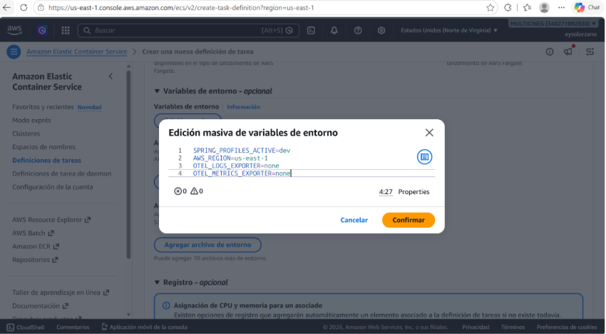
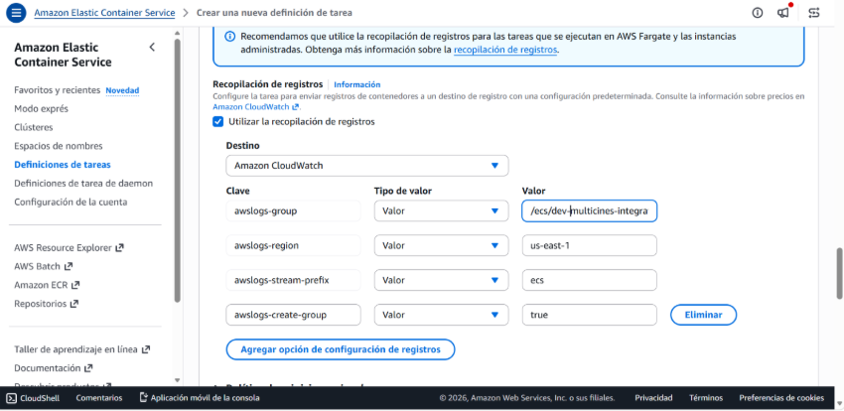

10.5 Sidecar ADOT (X-Ray)
Parámetro | Valor
Container | aws-otel-collector
Image | public.ecr.aws/aws-observability/aws-otel-collector:latest
Essential | No
Memory | 256 MB
Puerto | 4317/tcp (gRPC OTLP)

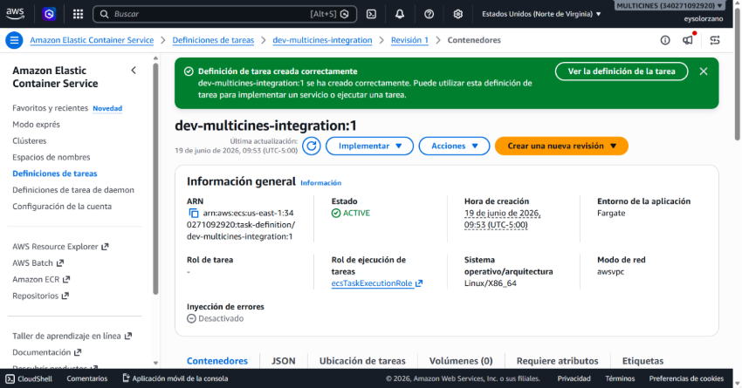
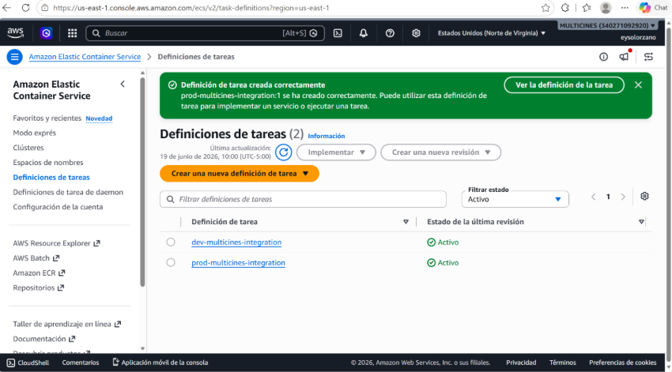

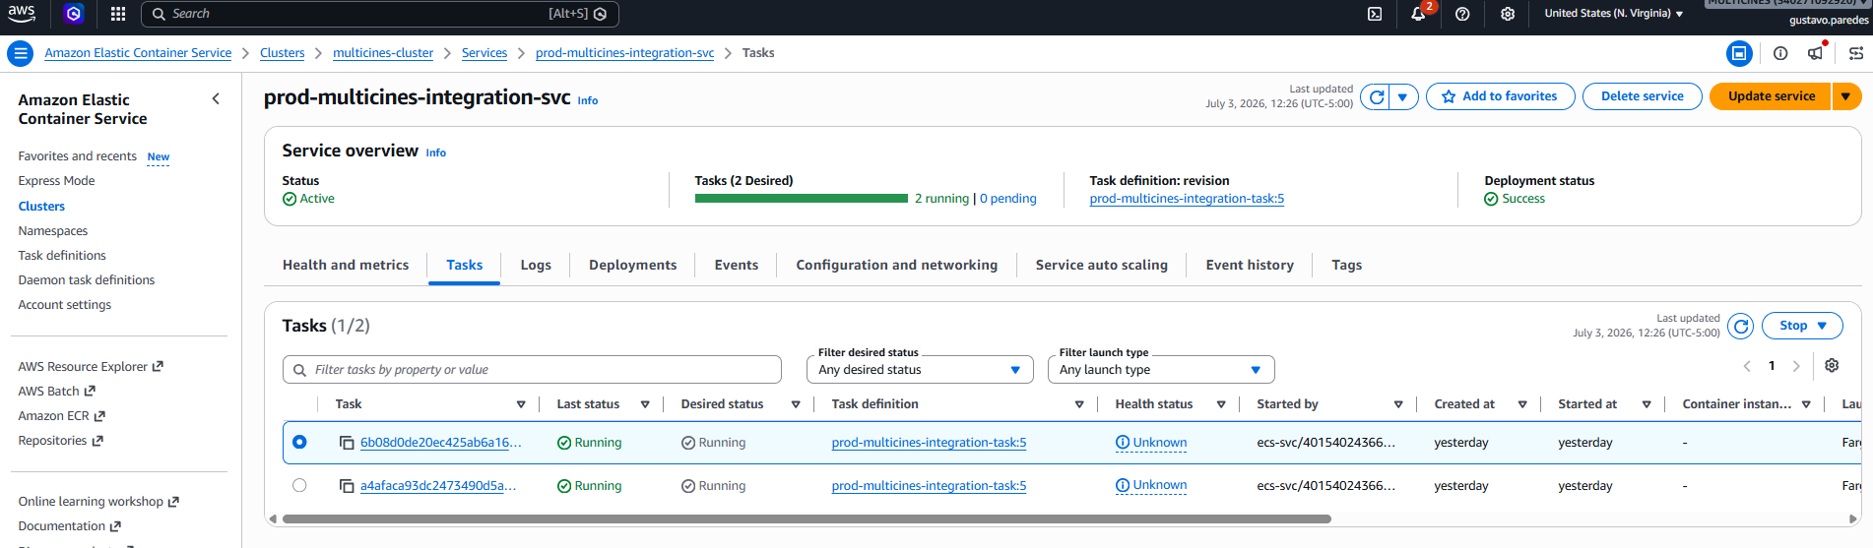

⌨ AWS CLI
# Crear cluster
aws ecs create-cluster --cluster-name multicines-cluster --region us-east-1

# Registrar Task Definition (desde JSON)
aws ecs register-task-definition --cli-input-json file://task-def.json --region us-east-1

# Crear servicio (dev)
aws ecs create-service --cluster multicines-cluster \
--service-name dev-multicines-integration-svc \
--task-definition dev-multicines-integration-task \
--launch-type FARGATE --desired-count 1 --enable-execute-command \
--network-configuration 'awsvpcConfiguration={subnets=["subnet-0eeec60453f7f9492"],securityGroups=["sg-01c619444bab0b8d3"],assignPublicIp=DISABLED}' \
--load-balancers targetGroupArn=<TG_ARN>,containerName=integration-service,containerPort=8095 \
--health-check-grace-period-seconds 210 --region us-east-1

# Force new deployment (reiniciar tareas con nuevos secrets/config)
aws ecs update-service --cluster multicines-cluster \
--service dev-multicines-integration-svc --force-new-deployment --region us-east-1

# Esperar estabilidad
aws ecs wait services-stable --cluster multicines-cluster \
--services dev-multicines-integration-svc --region us-east-1

# Eliminar servicio
aws ecs update-service --cluster multicines-cluster --service dev-multicines-integration-svc --desired-count 0 --region us-east-1
aws ecs delete-service --cluster multicines-cluster --service dev-multicines-integration-svc --region us-east-1

11. Observabilidad — CloudWatch, X-Ray
Monitoreo completo: SNS para alertas, 7 alarmas CloudWatch, dashboard unificado, metric filters, y trazas X-Ray via sidecar ADOT.

11.1 SNS Topics
Topic | Email | Ambiente
dev-multicines-integration-alarms | alarms@multicines.com.ec | dev
prod-multicines-integration-alarms | alarms@multicines.com.ec | prod

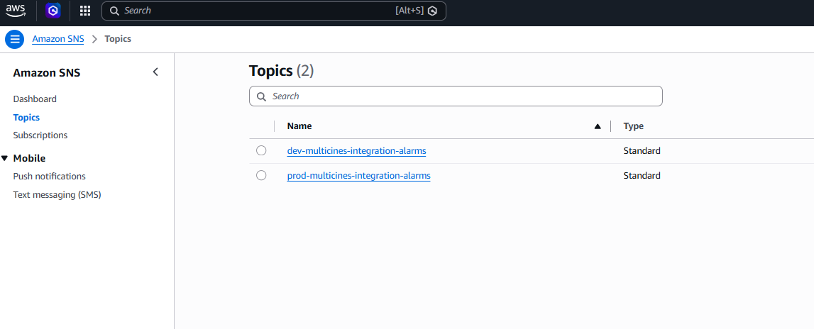

11.2 CloudWatch Alarms
Alarma | Métrica | Threshold | Estado
alarm-cpu-high | AWS/ECS CPUUtilization | ≥ 80% | OK
alarm-memory-high | AWS/ECS MemoryUtilization | ≥ 80% | OK
alarm-5xx | ALB HTTPCode_Target_5XX_Count | ≥ 10 | INSUFFICIENT_DATA
alarm-4xx | ALB HTTPCode_Target_4XX_Count | ≥ 50 | OK
alarm-unhealthy-hosts | ALB UnHealthyHostCount | ≥ 1 | OK
alarm-response-time-high | ALB TargetResponseTime | ≥ 5s/3s | OK
alarm-no-running-tasks | ECS RunningTaskCount | < 1 | OK

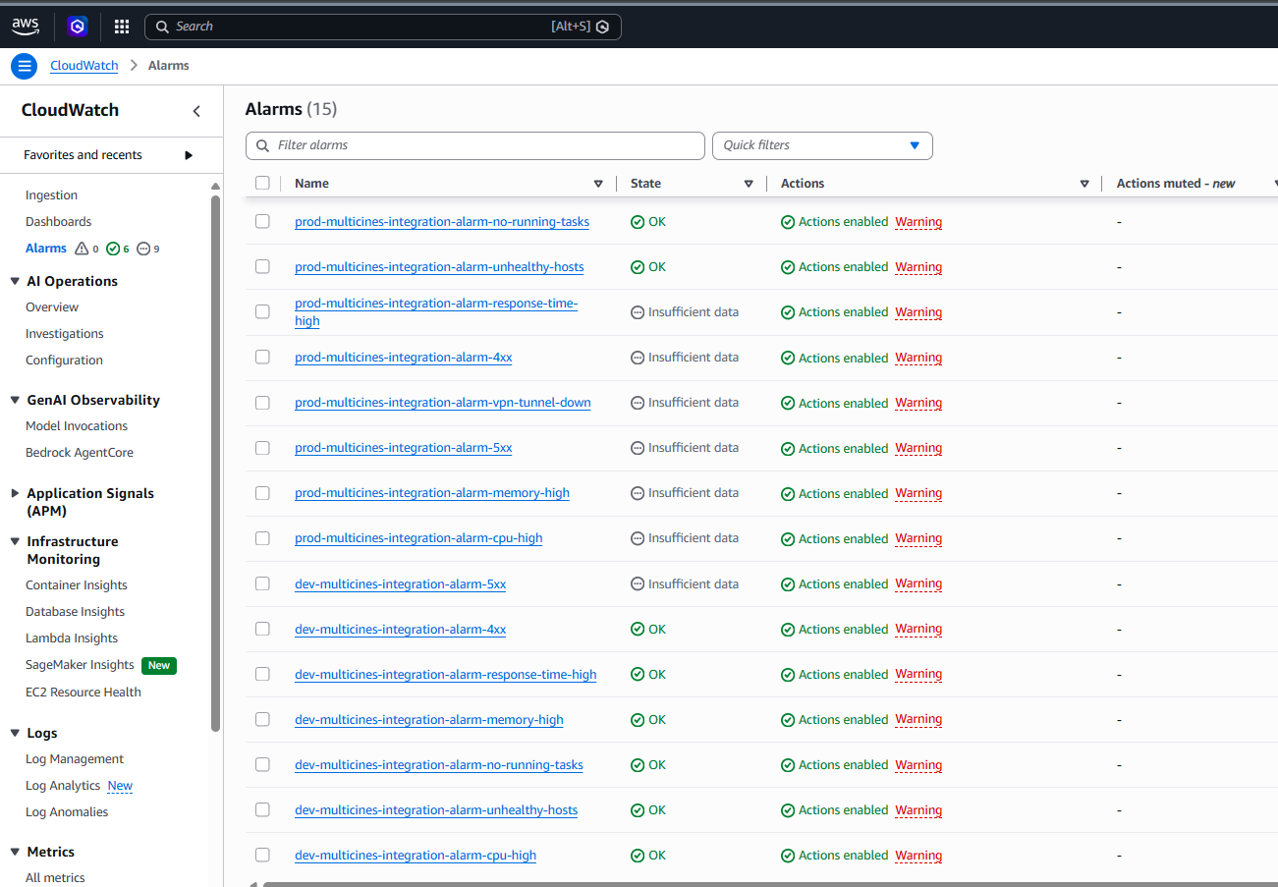

11.3 CloudWatch Dashboard
Dashboard | Ambiente
dev-multicines-integration-dashboard | dev
prod-multicines-integration-dashboard | prod

Widgets: CPU, Memory, Request Count, 5xx, 4xx, Response Time, Healthy/Unhealthy, Custom Metrics, Running Tasks.

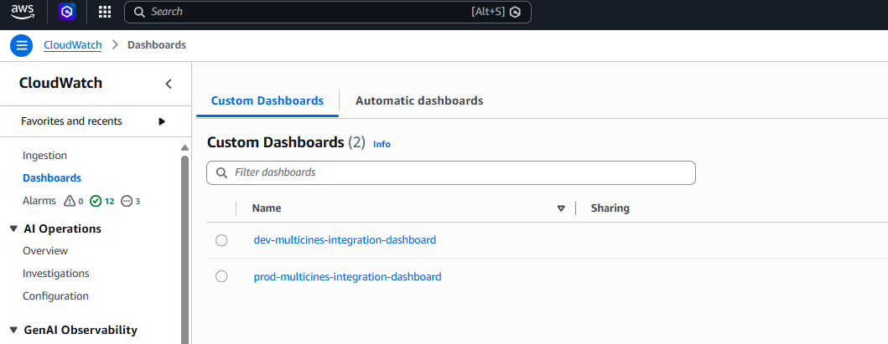
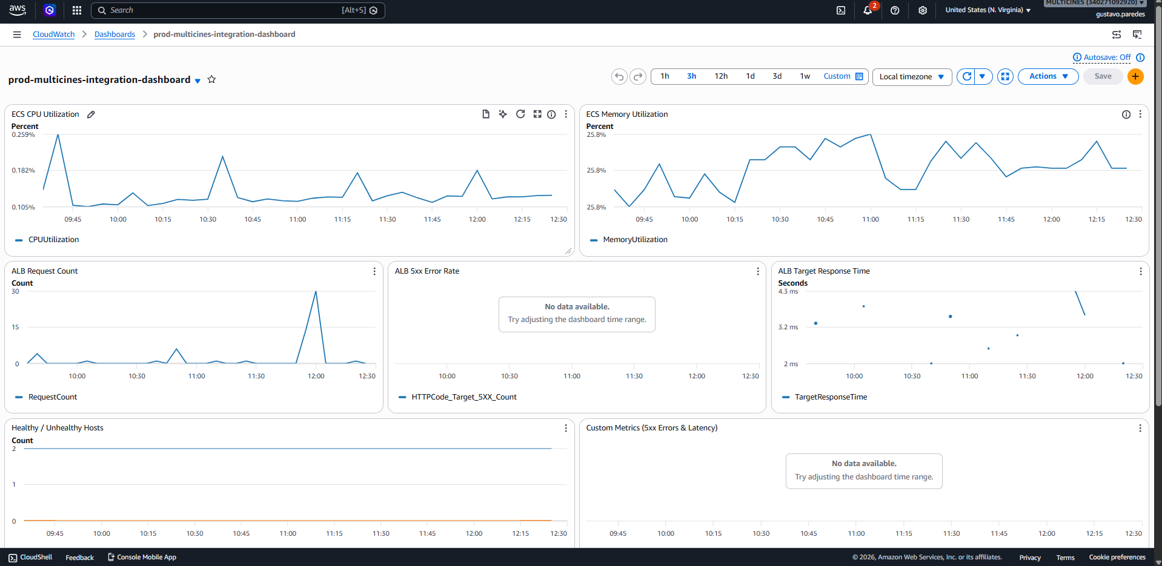

11.4 Log Metric Filters
Filter | Pattern | Metric
filter-5xx-errors | { $.status >= 500 } | 5xxErrors (Multicines/{env})
filter-latency | { $.duration_ms = * } | Latency (Multicines/{env})

11.5 X-Ray
El sidecar ADOT exporta trazas a X-Ray. Visualizar en: X-Ray → Traces → filtrar por servicio: integrator

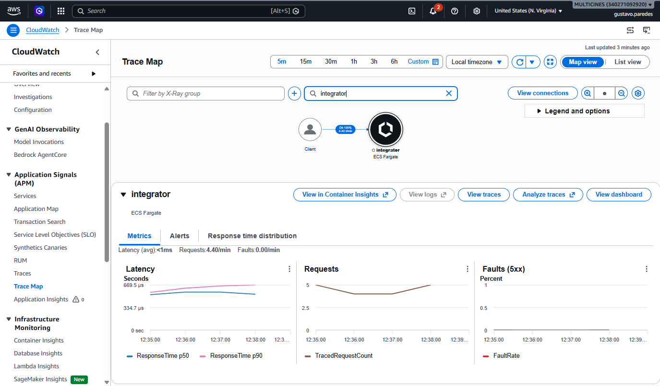

⌨ AWS CLI
# Crear SNS Topic + suscripción
aws sns create-topic --name dev-multicines-integration-alarms \
--tags Key=Name,Value=dev-multicines-integration-alarms Key=Project,Value=multicines --region us-east-1
aws sns subscribe --topic-arn <TOPIC_ARN> --protocol email \
--notification-endpoint alarms@multicines.com.ec --region us-east-1

# Crear alarma (ejemplo: CPU alta)
aws cloudwatch put-metric-alarm --alarm-name dev-multicines-integration-alarm-cpu-high \
--namespace AWS/ECS --metric-name CPUUtilization \
--dimensions Name=ServiceName,Value=dev-multicines-integration-svc Name=ClusterName,Value=multicines-cluster \
--statistic Average --period 300 --evaluation-periods 2 --threshold 80 \
--comparison-operator GreaterThanOrEqualToThreshold \
--alarm-actions <SNS_TOPIC_ARN> --region us-east-1

# Crear dashboard
aws cloudwatch put-dashboard --dashboard-name dev-multicines-integration-dashboard \
--dashboard-body file://dashboard.json --region us-east-1

# Crear metric filter
aws logs put-metric-filter --log-group-name /ecs/dev-multicines-integration \
--filter-name dev-multicines-integration-filter-5xx-errors \
--filter-pattern '{ $.status >= 500 }' \
--metric-transformations metricName=5xxErrors,metricNamespace=Multicines/dev,metricValue=1 --region us-east-1

# IAM Policy X-Ray
aws iam put-role-policy --role-name multicines-ecs-task-role \
--policy-name dev-multicines-integration-xray-policy \
--policy-document file://xray-policy.json

# Listar alarmas
aws cloudwatch describe-alarms --alarm-name-prefix dev-multicines-integration --region us-east-1

# Eliminar alarmas
aws cloudwatch delete-alarms --alarm-names <ALARM1> <ALARM2> --region us-east-1

12. VPN Site-to-Site
Conexión VPN IPSec entre AWS y la red on-premise de Multicines (IP: 200.7.217.58). Ambos ambientes comparten el mismo Customer Gateway.

12.1 Estado actual
Recurso | ID | Nombre | Ambiente
VPN Connection | vpn-08add07f10aaf549d | dev-multicines-integration-vpn | dev
VPN Connection | vpn-03ad7d548894fe350 | prod-multicines-integration-vpn | prod
Virtual Private GW | vgw-0d4a9bbfacc384bdc | dev-multicines-integration-vgw | dev (vpc-0a5ebea8e7bee9ed5)
Virtual Private GW | vgw-0954e2b1a370ae78e | prod-multicines-integration-vgw | prod (vpc-0860a0d2cf4df6140)
Customer Gateway | cgw-090efcb086447cd1a | cgw-multicines (IP: 200.7.217.58) | compartido

12.2 Customer Gateway
1. VPC → Customer Gateways → Create Customer Gateway
2. Name: cgw-multicines
3. Routing: Static
4. IP Address: 200.7.217.58 (IP pública router Multicines)
5. BGP ASN: 65000 → Create

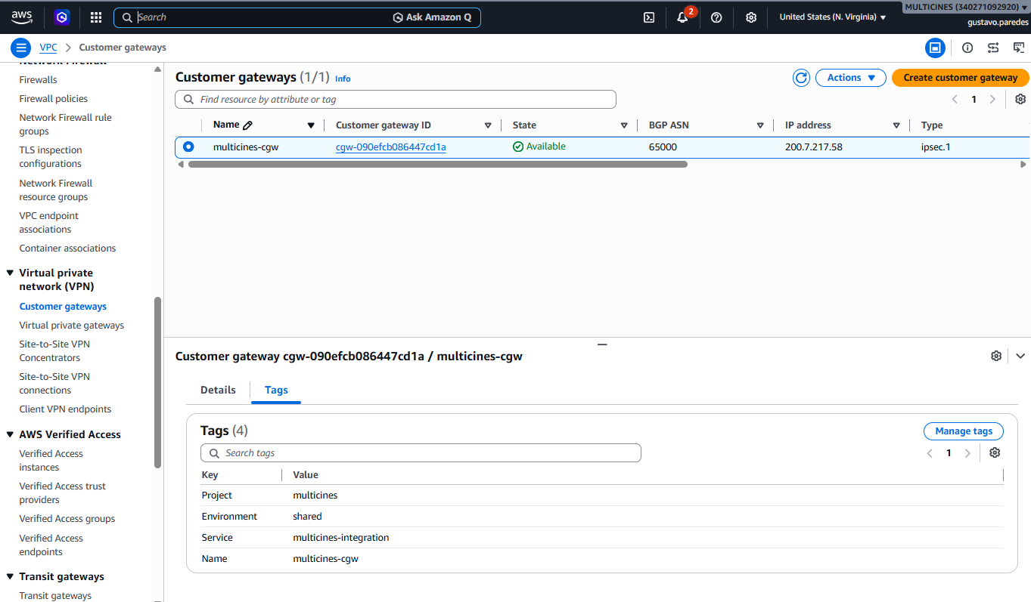

12.3 Virtual Private Gateway
1. VPC → Virtual Private Gateways → Create Virtual Private Gateway
2. Name: {env}-multicines-integration-vgw → Create
3. Actions → Attach to VPC → seleccionar VPC del ambiente

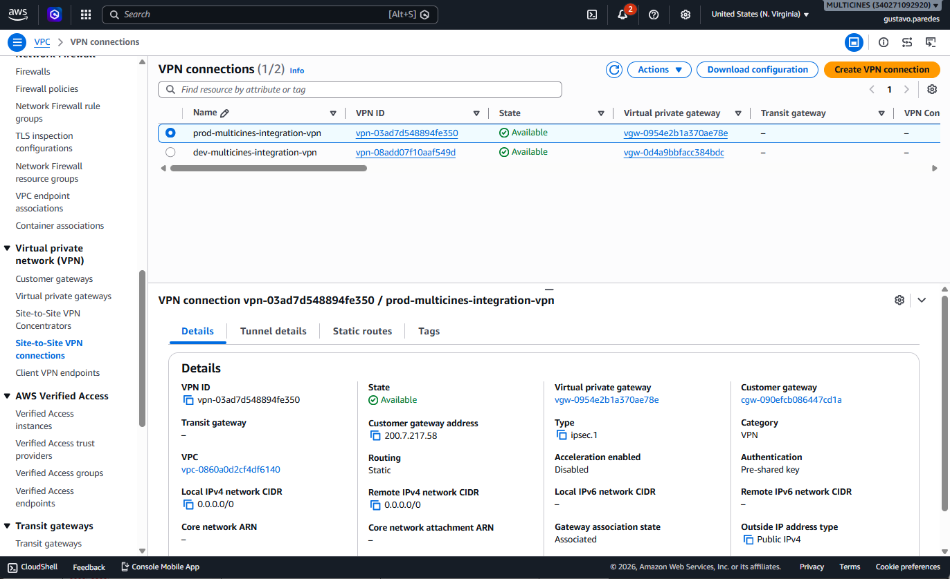

12.4 VPN Connection
1. VPC → Site-to-Site VPN Connections → Create VPN Connection
2. Name: {env}-multicines-integration-vpn
3. Target Gateway: VGW creado
4. Customer Gateway: cgw-multicines (cgw-090efcb086447cd1a)
5. Routing: Static → Create
6. Download Configuration para configurar router on-premise

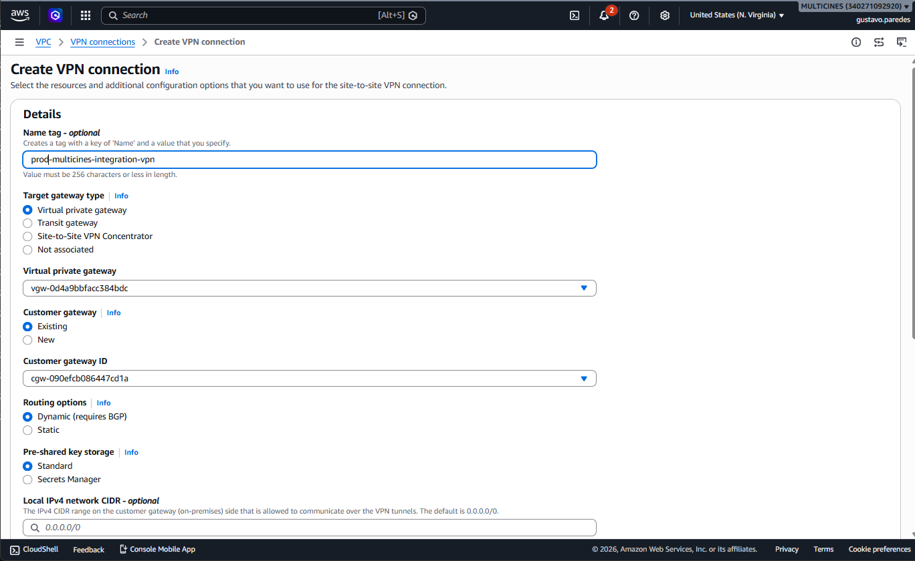

12.5 Route Propagation
1. VPC → Route Tables → tabla privada del ambiente
2. Route propagation → Edit → habilitar para VGW → Save
3. Verificar ruta 192.168.0.0/16 → VGW aparece en Routes

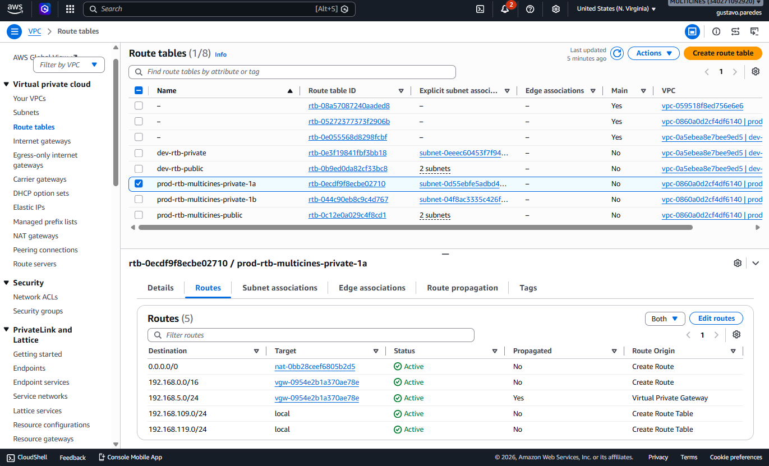

12.6 Configuración de Red
Parámetro | Dev | Prod
VPN Connection | vpn-08add07f10aaf549d | vpn-03ad7d548894fe350
VGW | vgw-0d4a9bbfacc384bdc | vgw-0954e2b1a370ae78e
CGW | cgw-090efcb086447cd1a (compartido) | cgw-090efcb086447cd1a (compartido)
Customer IP | 200.7.217.58 | 200.7.217.58
BGP ASN | 65000 | 65000
Ruta on-premise | 192.168.0.0/16 → VGW | 192.168.0.0/16 → VGW
VPC | vpc-0a5ebea8e7bee9ed5 | vpc-0860a0d2cf4df6140

⌨ AWS CLI
# Crear Customer Gateway (compartido)
aws ec2 create-customer-gateway --type ipsec.1 --public-ip 200.7.217.58 --bgp-asn 65000 \
--tag-specifications 'ResourceType=customer-gateway,Tags=[{Key=Name,Value=cgw-multicines}]' \
--region us-east-1

# Crear Virtual Private Gateway (por ambiente)
aws ec2 create-vpn-gateway --type ipsec.1 \
--tag-specifications 'ResourceType=vpn-gateway,Tags=[{Key=Name,Value=dev-multicines-integration-vgw}]' --region us-east-1
aws ec2 attach-vpn-gateway --vpn-gateway-id vgw-0d4a9bbfacc384bdc --vpc-id vpc-0a5ebea8e7bee9ed5 --region us-east-1

# Crear VPN Connection
aws ec2 create-vpn-connection --type ipsec.1 \
--customer-gateway-id cgw-090efcb086447cd1a --vpn-gateway-id vgw-0d4a9bbfacc384bdc \
--tag-specifications 'ResourceType=vpn-connection,Tags=[{Key=Name,Value=dev-multicines-integration-vpn}]' --region us-east-1

# Habilitar route propagation
aws ec2 enable-vgw-route-propagation --gateway-id vgw-0d4a9bbfacc384bdc \
--route-table-id <RTB_PRIVATE_ID> --region us-east-1

# Verificar estado de túneles
aws ec2 describe-vpn-connections --vpn-connection-ids vpn-08add07f10aaf549d \
--query "VpnConnections[0].VgwTelemetry[].{Status:Status,IP:OutsideIpAddress}" --region us-east-1

# Actualizar tags
aws ec2 create-tags --resources vpn-08add07f10aaf549d \
--tags Key=Name,Value=dev-multicines-integration-vpn Key=Project,Value=multicines Key=Environment,Value=dev --region us-east-1

13. CI/CD — GitHub Actions

13.1 Proveedor OIDC
1. IAM → Identity providers → Add provider
2. Type: OpenID Connect
3. URL: https://token.actions.githubusercontent.com
4. Audience: sts.amazonaws.com → Add provider
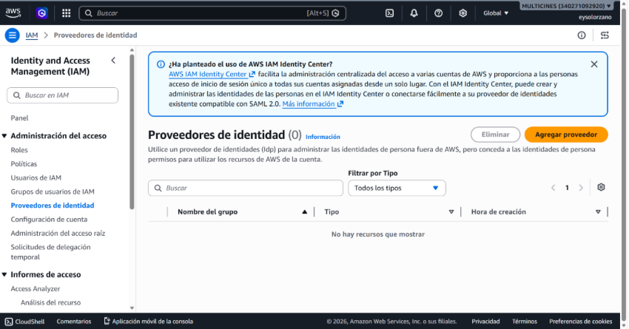
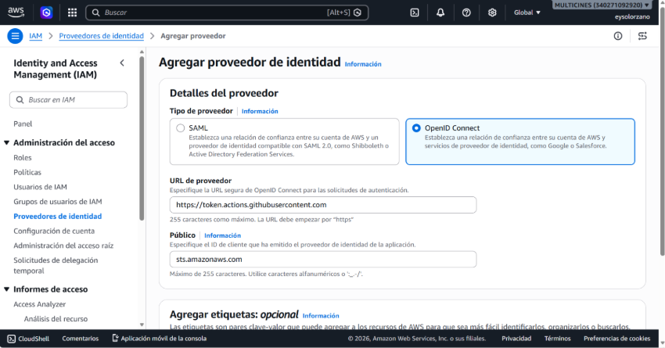
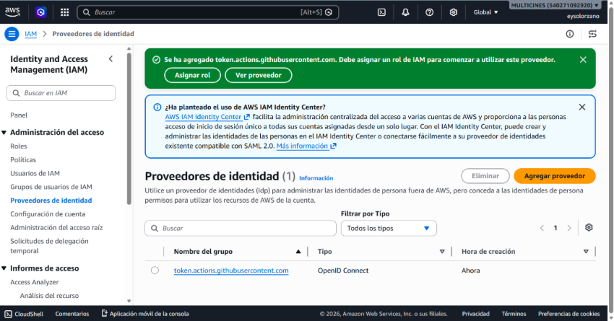

13.2 Rol IAM GitHub Actions
Rol: multicines-github-actions-role | ARN: arn:aws:iam::340271092920:role/multicines-github-actions-role
Políticas: AmazonECS_FullAccess + AmazonEC2ContainerRegistryPowerUser
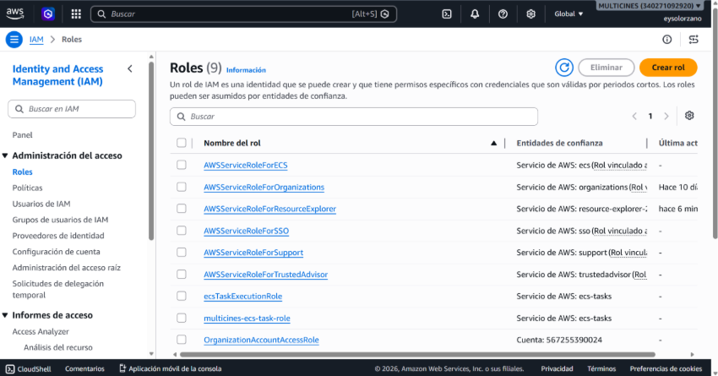
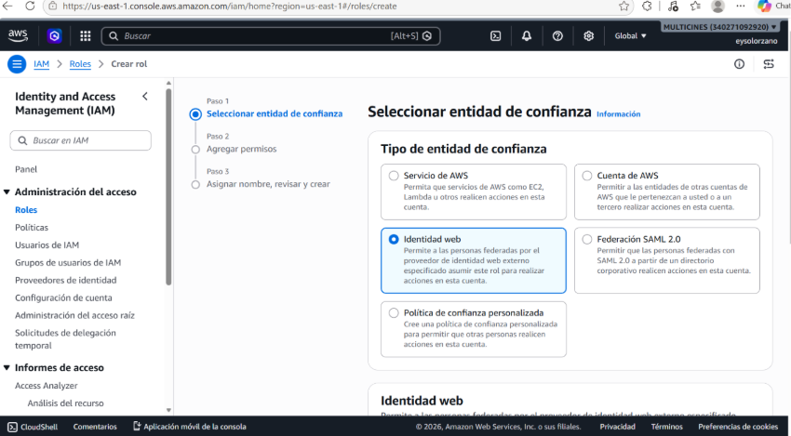
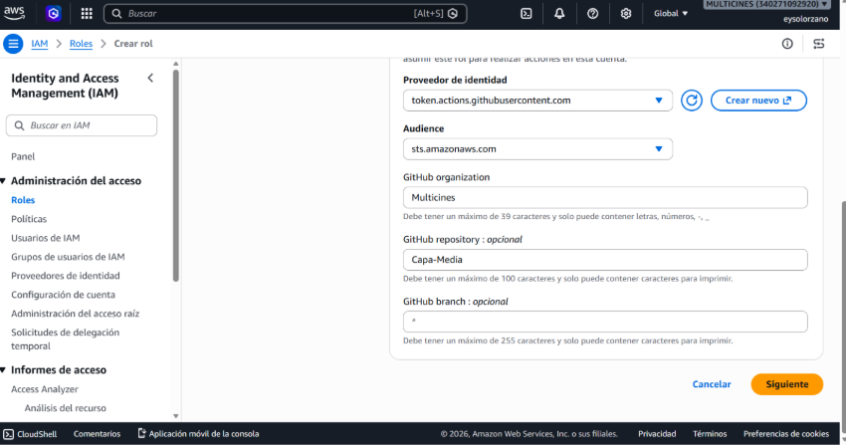
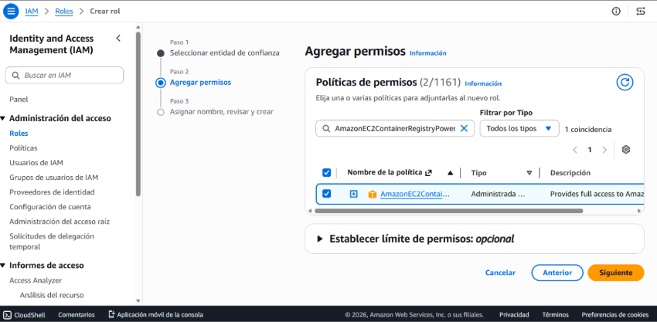
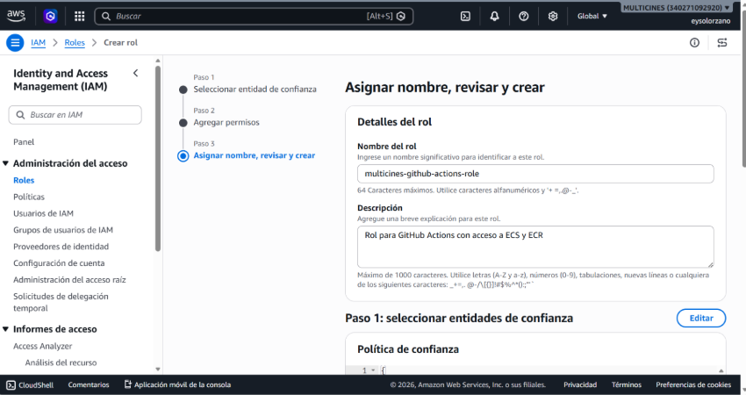
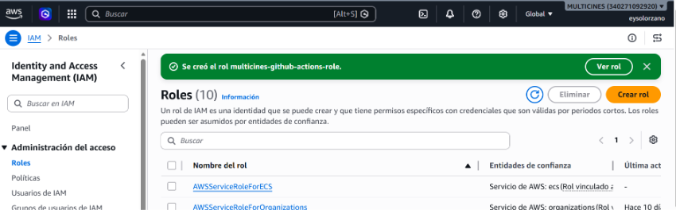

13.3 Variables y Secrets en GitHub
Variable | Valor
AWS_REGION | us-east-1
DEV_CONTAINER_NAME | integration-service
DEV_ECS_SERVICE | dev-multicines-integration-svc
DEV_ENVIRONMENT | dev-lastest
DEV_TASK_DEFINITION | dev-multicines-integration-task
ECR_REPOSITORY | multicines/integration-service
ECS_CLUSTER | multicines-cluster
PROD_CONTAINER_NAME | integration-service
PROD_ECS_SERVICE | prod-multicines-integration-svc
PROD_ENVIRONMENT | lastest
PROD_TASK_DEFINITION | prod-multicines-integration-task

Secret | Valor
AWS_ROLE_ARN | arn:aws:iam::340271092920:role/multicines-github-actions-role

13.4 Pipeline
Workflow | Trigger | Ambiente
deploy-dev.yml | Push a dev | development
deploy-prod.yml | Push a main | production

Flujo: Checkout → OIDC Auth → ECR Login → Build Docker → Push → Update TD → Deploy ECS → Verify → (On failure: Rollback)

13.5 Protección de ramas
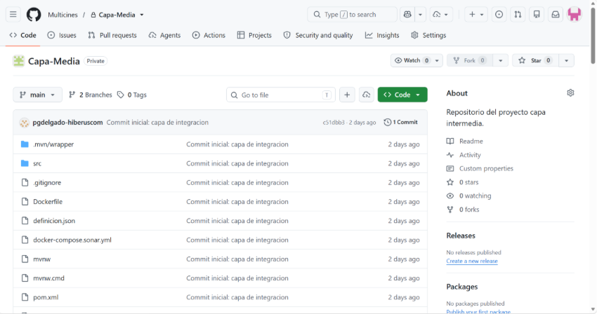
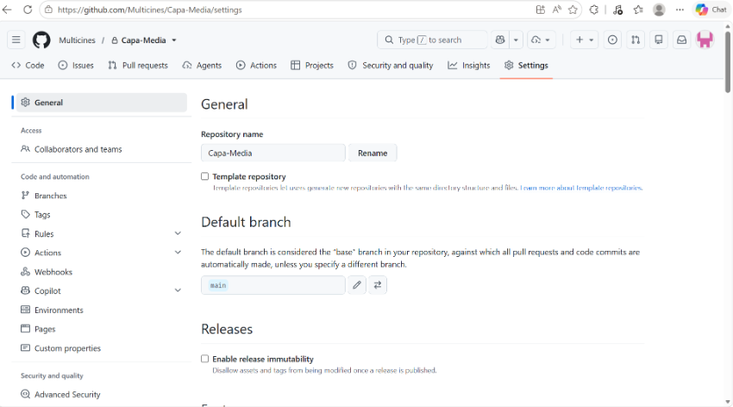
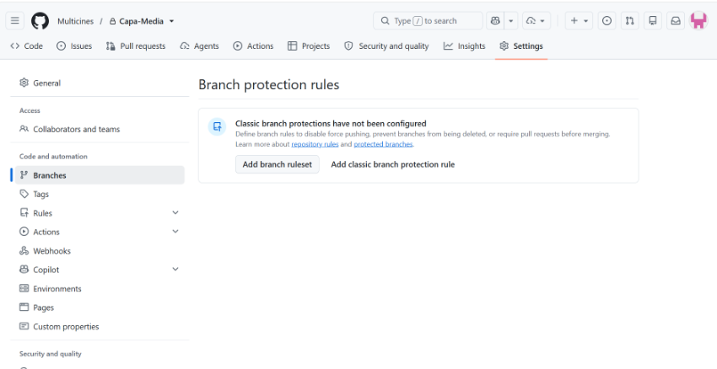
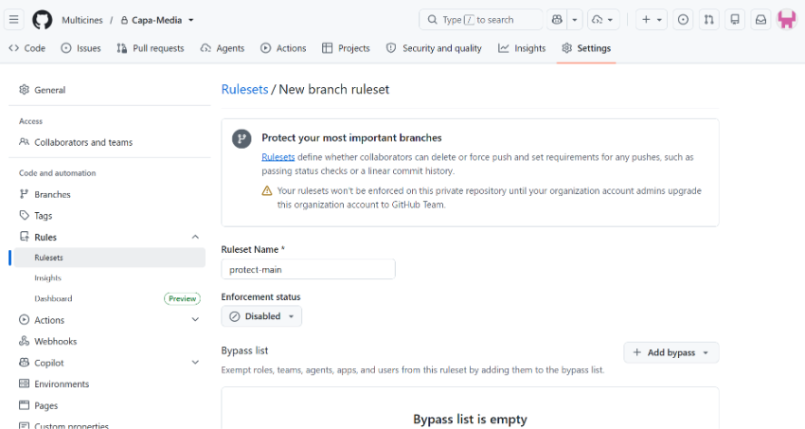
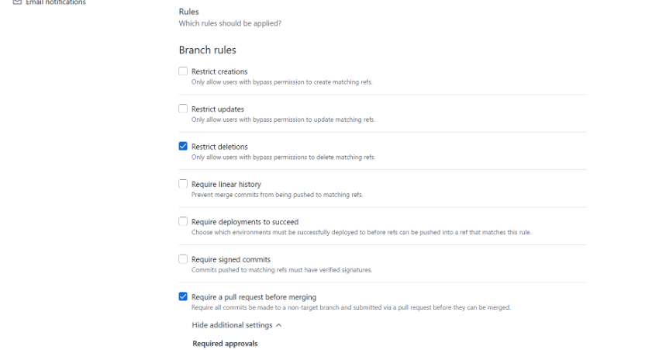
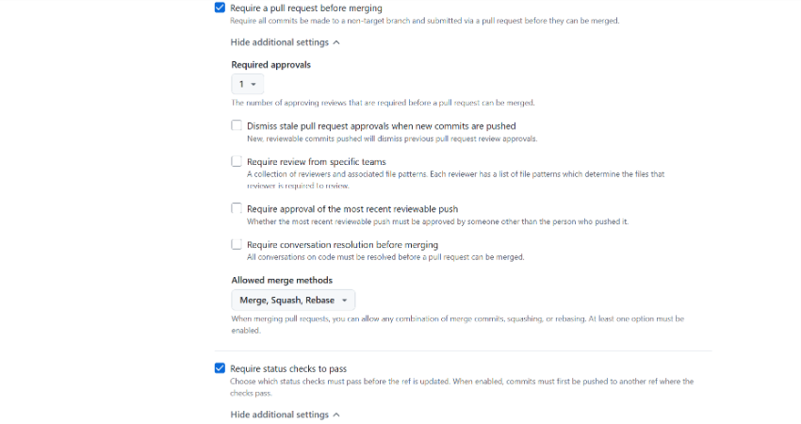
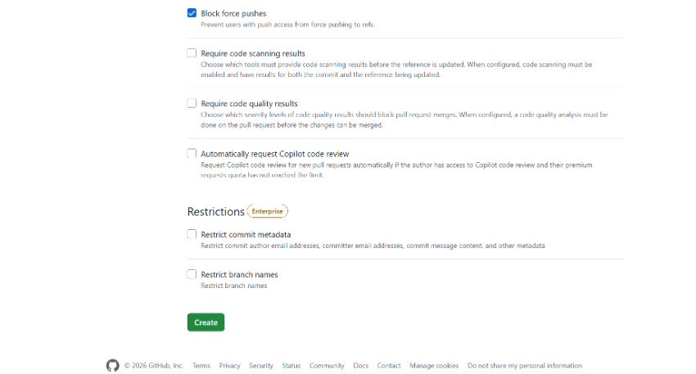

⌨ AWS CLI
# Crear OIDC provider
aws iam create-open-id-connect-provider \
--url https://token.actions.githubusercontent.com \
--client-id-list sts.amazonaws.com

# Crear rol GitHub Actions
aws iam create-role --role-name multicines-github-actions-role \
--assume-role-policy-document file://github-trust-policy.json
aws iam attach-role-policy --role-name multicines-github-actions-role \
--policy-arn arn:aws:iam::aws:policy/AmazonECS_FullAccess
aws iam attach-role-policy --role-name multicines-github-actions-role \
--policy-arn arn:aws:iam::aws:policy/AmazonEC2ContainerRegistryPowerUser

